DEPARTMENT OF ELECTRONIC COMMUNICATIONS
DEPUTY MINISTRY OF RESEARCH, INNOVATION AND DIGITAL POLICY

NATIONAL BROADBAND PLAN
2021-2025

NICOSIA
June 2021

Contents
1 Executive Summary 4
2 Increasing demand for data and bandwidth 6
2.1 Fixed VHCN 7
Topologies 7
State of play in Europe 7
Fibre as an enabling technology 8
Socio-Economic impact 8
Copper switch-off 9
2.2 Mobile VHCN 9
What is 5G 9
5G across the world 11
5G as a technology enabler 11
The deployment path of 5G 12
Socio-economic impact 13
3 European Union context 15
3.1 Policies 15
3.2 Financing mechanisms 16
4 National context 17
4.1 Digital Strategy for Cyprus 17
4.2 Electronic Communication services and the connectivity sector 18
Fixed 18
Mobile 19
Cyprus and cross-border connectivity infrastructures 21
Satellite facilities in Cyprus 21
Data centres 22
4.3 DESI connectivity ranking 22
4.4 Assessment of the current state 23
Mapping of private investment plans 23
Consultation on Connectivity roadmap 25
5G opportunities and benefits for Cyprus beyond commercial deployments and eMBB 25
4.5 Diagnosis 29
Strengths 29
Opportunities 30
Weaknesses 30
Threats 31
5 Vision, objectives and targets 32
6 Actions 33
6.1 Objective A: Promote private investments as much as possible, remove administrative barriers and encourage stakeholders’ co-operation 33
A1. Introduce permit exemptions and fast track procedures and promote the application of existing lighter permit granting procedures (BP-1) 33
A2. Provide model regulations on electronic communications network deployment (BP-2) 34
A3. Provide informative materials and workshops for municipalities and other competent authorities (BP-3) 34
A4. Digital administrative portal/single information point (SIP) coordination (BP-5) 34
A5. Ensure the availability of information from different sources and enhance transparency of planned civil works (BP-11) 34
A6. Ensure access to physical infrastructure controlled by public bodies (BP-16) 35
A7. Timely availability of 5G harmonised bands (BP-25) 35
A8. Coordinated and targeted communication for informing and educating on 5G implementation (BP-38) 36
Α9. Strengthening the role of Broadband Competence Office (BCO) 36
6.2 Objective B: Ensure comprehensive availability and the widest adoption of ultrafast broadband services 36
Β1. Expansion of Very High Capacity Networks in underserved areas 36
Β2. Enhance building cabling to be “Gigabit-ready” and promote connectivity take-up 39
Β3. Submarine cable system to Greece 40
B4. Address the affordability of ultrafast services 40
B5. Facilitate the installation of Data Center infrastructures 41
7 Governance 43
8 Security considerations 44
Abbreviations 46
Endnotes 48

Executive Summary
Today, Cyprus has a comprehensive coverage of fast broadband infrastructures, both in fixed and mobile: Since the sector liberalisation almost two decades ago, operator-led investments have resulted to a significant improvement and coverage of connectivity infrastructures, facilities and services. The role of the public sector was to ensure balanced development, by establishing a legislative / regulatory framework to promote such investments while assuring a sound level of competition in the market.
The very high quality and affordability of digital connectivity is key for the development of the economy and for territorial and social cohesion. The COVID-19 pandemic highlighted the vulnerability of our economies and societies and radically changed the role of digital services in our everyday lives. It accelerated the demand for connectivity services, with data traffic volumes exploding by nearly 70%, as people rely entirely on digital services to work and study from home, connect with family and friends or shop online. In Cyprus, there was an average increase of 39% in fixed and 50% in mobile broadband data consumption. The criticality of digital infrastructures in the modern world is acknowledged in the EU budgetary reaction in the form of the Recovery and Resilience Fund, in which digital transformation constitutes one of the key pillars.
Within the EU, Cyprus ranks 23rd out of the 27 EU Member States in the digital sector. Particularly in the connectivity dimension, Cyprus ranks 26th, lagging particularly behind in coverage and take-up of ultrafast services and prices. A leap forward is necessary in order for the economy and the society to reap the benefits of the digital transition. Furthermore, Cyprus can leverage its geographical position to become a data gateway to the EU for the middle-east countries.
The Broadband Plan lays the foundations for the digital transition of the country, empowered by robust, reliable and affordable network infrastructures, fully aligned with the digital infrastructure portfolio of the Cyprus Digital Strategy (see chapter 4.1). The vision of the Broadband Plan is
"To perform a leap in digital connectivity by 2025, so as to enable the digital transition of the society and economy and to strengthen its role as regional data gateway for the EU"
A set of reforms and investments are proposed, aimed at assuring comprehensive availability of very high capacity networks (both fixed and mobile) and strong take-up of the ultrafast services. The key objectives of the Plan are to:
- Promote private investments as much as possible, remove administrative barriers and encourage stakeholders’ co-operation
- Ensure comprehensive availability and the widest adoption of ultrafast broadband services
Objective A is supported by a series of measures including:
- Introduction of permit exemptions and fast track procedures and promotion of the application of existing lighter permit granting procedures
- Updatethe , if requiredProvision of informative materials and workshops for municipalities and other competent authorities
- Enhancement of the digital administrative portal/single information point (SIP) coordination
- Ensure the availability of information from different sources and enhance transparency of planned civil works
- Ensure access to physical infrastructure controlled by public bodies
- Timely availability of 5G harmonised bands
- Coordinated and targeted communication for informing and educating on 5G implementation
- Strengthening the role of Broadband Competence Office
Objective B is supported by a series of key public intervention measures, addressing:
- Expansion of Very High Capacity Networks in underserved areas
- Enhance building cabling to be “Gigabit-ready” and promote connectivity take-up
- Submarine cable system to Greece
- Address the affordability of ultrafast services
Public investment in the context of the Broadband Plan amounts to 72.5 million euros over the period 2021-2027.
The Broadband Plan needs the active involvement of all respective stakeholders. It is conceived as a public-private collaboration effort, in the execution of which Ministries, Public Authorities, Local Administrations and Communities should actively participate to support private stakeholders towards the achievement of its vision.
The diagnosis of the situation presented in this Plan, as well as its objectives and measures, have been prepared with the close collaboration of the Deputy Ministry of Innovation Research and Digital Policy (DMIRD), the Department of Electronic Communications (DEC) and the Office of the Commissioner for Electronic Communications and Postal Regulation (OCECPR). The main stakeholders of the industry will be consulted and taken into account, in order to make this Plan a participative instrument of public-private collaboration that will contribute to the Digital Transformation of Cyprus.
The Broadband Plan is aligned with the European Union’s policy objectives as regards the transition of Europe towards a Gigabit Society. It describes the landscape shaped by the growing demand for data and high-speed broadband (Chapter 2), examines the European policy framework (Chapter 3), analyzes the local market and diagnoses the situation in Cyprus (Chapter 4), sets out the vision, goals and objectives of the Broadband Plan (Chapter 5) and identifies areas and methods of public intervention and support actions (Chapter 6), as well as the governance structure (Chapter 7) to implement them.

Increasing demand for data and bandwidth
A number of major technology breakthroughs are underway and will eventually transform the way we live. In the future, we will be able to fully immerse in virtual realities, blurring the line between reality and fiction. Virtual and augmented reality will provide new opportunities in multiple sectors (e.g. virtual classrooms that enable students to learn together as if they were in situ, remote healthcare including diagnostics, therapy and surgery and of course entertainment). The Fourth Industrial Revolution (Industry 4.0) changes the way products are manufactured and consumed by creating unprecedented levels of automation and performance through a combination of exponential technologies like 5G, Industrial Internet of Things (IoT), augmented reality (AR), big data and artificial intelligence. A new data-driven economy is emerging with massive amounts of data collected and exchanged, making possible the complete automation of entire sectors of the economy. In the near future, wirelessly connected devices and sensors will monitor processes or, even, the physical environment and optimally respond in real-time without any human intervention based on artificial intelligence. The digitisation of entire sectors, from “smart” factories operating autonomously to “smart” goods that foresee consumers’ needs, autonomous vehicles, smart energy grids, healthcare (robot-assisted surgery), smart cities and agriculture, will change the way the economy and society are organised. The Covid-19 pandemic has accelerated the need for bandwidth and even with the riddance of the pandemic a significant residual effect in data consumption is expected to remain.
Very High Capacity Networks with ultra-high bandwidth, very low latency, ultra-high reliability and availability as well as high security standards will be the enabling infrastructure to drive economic growth and make this revolution possible. Full fibre access at fixed locations (FTTH) and 5G are transforming productivity, enabling new business models. Everyday activities (teleworking, virtual presence, online learning, AR, video and music streaming etc.) requiring the exchange of multiple GBytes per day are shaping the needs for future proof, reliable and resilient network infrastructures. ‘Very High Capacity Network’ (VHCN) means either an electronic communications network which consists wholly of optical fibre elements at least up to the distribution point at the serving location, or an electronic communications network which is capable of delivering, under usual peak-time conditions, similar network performance in terms of available downlink and uplink bandwidth, resilience, error-related parameters, and latency and its variation. In accordance with the EECC, BEREC has provided guidelines on the criteria to be applied as regards the qualification of a Very High Capacity Network. Although the available bandwidth is the primary characteristic of a VHCN, other key performance parameters (e.g. latency, availability and reliability) are also taken into account.
In the case of fixed-line connection, the aforementioned definition of VHCN corresponds to network performance equivalent to that achievable by an optical fibre installation up to a multi-dwelling building. Therefore, only FTTB and FTTH networks can be qualified as VHCN. If this criterion is not met, the qualification of a network as Very High Capacity Network should be assessed against specific performance parameters: the downlink data rate should exceed 1000 Mbps and the uplink should exceed 200 Mbps while other performance criteria should also be met.
In the case of wireless connection, this corresponds to network performance similar to that achievable based on an optical fibre installation up to the base station. If this criterion is not met, the qualification of a network as Very High Capacity Network should be assessed against specific performance parameters. More precisely, in order for a wireless network to be qualified as a Very High Capacity Network, the downlink data rate should exceed 150 Mbps and the uplink should exceed 50 Mbps while other performance criteria should also be met.

Fixed VHCN

Topologies
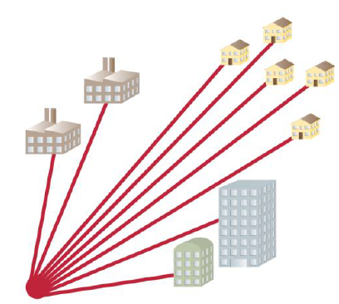
While FTTB is common in countries with many high-rise buildings hosting tens or even hundreds of apartments, FTTH is more widespread globally and is more suitable in countries with predominantly low-rise buildings like Cyprus. FTTH is the most reliable and future-proof technology, capable of providing symmetric Gigabit and low-latency broadband services speeds and can be deployed according to two different network topologies:
Point-to-Point (P2P): a dedicated fibre is available from the access node to a specific customer premise. The capacity of each fibre is not shared and, thus, it can provide higher bandwidth.
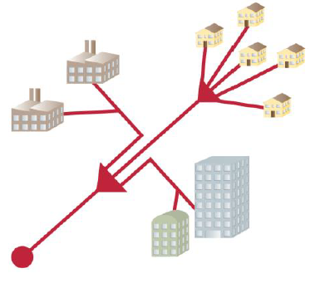
Point-to-Multipoint (P2MP), in which one fibre is splitted to multiple fibres in the field, with the possibility to use different splitting ratios and splitting points. Since capacity is shared, the higher the splitting ratio, the lower the maximum bandwidth per customer that can be supported. While the two topologies are equally common, P2MP is expected to become predominant in the coming years, particularly due to the cost advantages that it presents.

State of play in Europe
Fixed VHCN networks are heavily being deployed across the world. While only few countries have achieved almost ubiquitous coverage, in many countries coverage exceeds 50% - among which 19 EU member states.
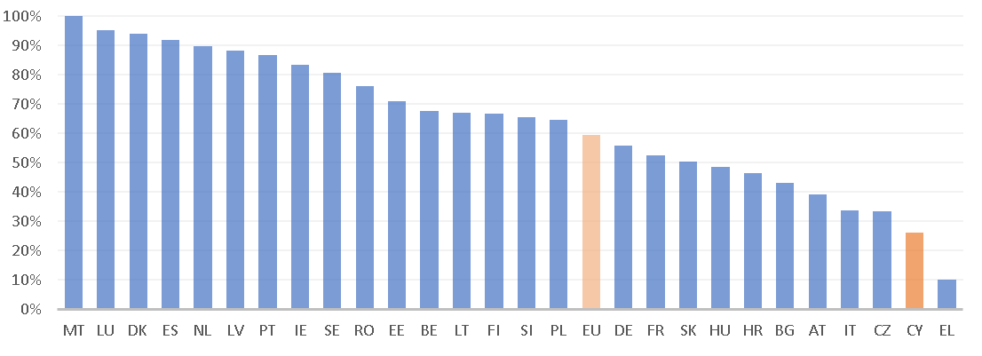
Figure 1: VHCN coverage in EU (source: DESI 2021)
Homes passed by FTTH already account for 105 million and are expected to double by 2026, while penetration to increase from 47% to 73%.
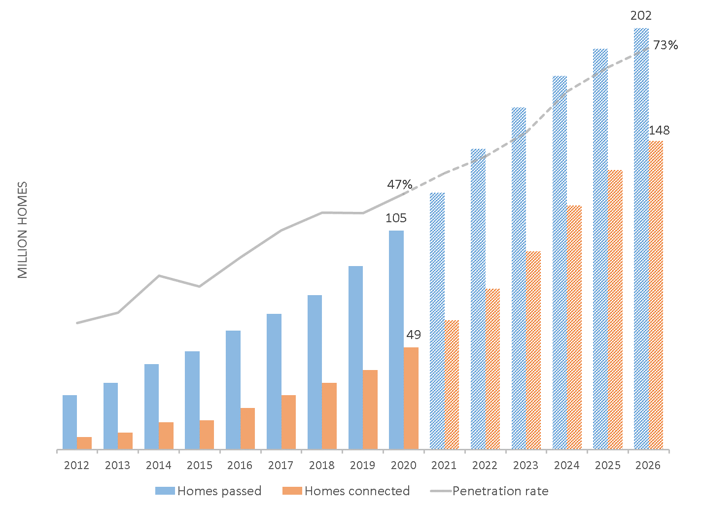
Figure 2: FTTH historical data and forecasts in EU 28 (2012-2026) (source: IDATE for FTTH Council Europe)

Fibre as an enabling technology
Fibre enables provision of ultrafast services in the most reliable way. Simultaneous use by multiple member of the family for bandwidth-hungry services like video conferencing and streaming stresses unreliable, low-speed connections. Particularly the introduction of 4K TV, while still at very early stage is interlinked with the availability of fibre networks and its wide adoption will only be enabled where extensive fibre is deployed. Video content in 4K offered by streaming platforms, premium sports, cultural events and thematic channels are expected to drive demand for FTTH services, to be followed by smart home applications and emerging technologies like virtual augmented reality and holographic communications. It should also be stretched that most of the broadband usage takes place at home: While pre-COVID European average usage was 203 GB per month, by 4Q20 it reached 301 GB per month, up 48% from a year earlier (in Cyprus average usage reached 231 GB per month during 4Q2020). Regarding mobile usage, although it also grew, it exceeded 10 GB per month in only 4 EU countries. While 5G is expected to deliver unprecedented mobile speeds further driving mobile usage, broadband usage will be dominated by fixed location access for many years to come.

Socio-Economic impact
The socio-economic impact of VHCN has been evaluated in several studies, which indicate strong positive impact on societies, economies and the environment:
- In Sweden for the majority of users, fibre is associated higher speed, wider range of services and better value for money. User satisfaction is also higher in the case of FTTH users compared to non-FTTH users, and most importantly, those users are more active online, also using music and video streaming platforms significantly more often. It was also shown that small municipalities offering digital home care services enabled by FTTH broadband can have a cost reduction of 75 to 425 € annually per capita, depending on the take-up rate of such services
- In the US, Teleworking is higher among FTTH users (working from home 12.8 days per month compared to an average of 10.8 days for DSL and cable users) and GDP per capita in areas with Gigabit is higher by 1.1%. Unemployment is also lower by 0.26%
- In France, municipalities with very high-speed broadband networks tend to attract 4.8% more start-ups providing a more favorable environment for entrepreneurship, with positive eﬀect the reduction of unemployment.
- In New Zealand, following the adoption of ultra fast broadband connection by a firm, the wages of certain skilled incumbent employees rise.
- In Canada, employment was shown to increase by 2.9% in areas fully covered by FTTH.
- FTTH/B has 88% less greenhouse gas emissions per gigabit compared to other access technologies. Based on the electricity consumption per bitrate, a study shows that copper-based networks (VDSL2 vectoring, super vectoring) consume up to seventeen times more electricity than fibre networks.

Copper switch-off
As fibre networks are rapidly deployed, the question regarding the future of existing copper networks arises. Clearly, in areas where FTTH has been widely deployed, it is no longer efficient to maintain the copper network as this would entail increased operational costs. This is the main driver for incumbent operators to consider copper switch-off in order to reduce operational costs and improve business cases. Moreover, the copper-switch-off has considerable socio-economics benefits (e.g. improved quality of service for end-users, reduced CO₂ emissions) driving governments and regulators to consider ways to facilitate it. However, only few countries have set clear targets concerning copper switch-off, but this will undoubtedly, be particularly relevant in the years to come. The swift copper switch-off can be facilitated by actions aiming at increasing the take-up of fibre-based services. From a policy perspective, copper switch-off should be facilitated but, in the same time, it should be ensured that competition would not be hindered.

Mobile VHCN

What is 5G
5G is the most promising and future-proof wireless technology capable to deliver data rates that were only possible through fixed networks. However, 5G is much more than a faster new generation of mobile networks. As defined by the International Telecommunications Union (ITU) in the IMT-2020, 5G promises enhanced performance compared to 4G by at least one order of magnitude in speed, latency and traffic capacity:
Key characteristic | 5G | Compared to 4G | Most relevant usage scenario | Indicative use cases
User experienced data rate (Mbit/s) | 100 | 10x | Enhanced Mobile Broadband (eMBB) | Ultra high definition video  Virtual / Augmented reality content  Cloud gaming
Peak data rate (Gbit/s) | 20 | 20x
Area traffic capacity (Mbit/s/m2) | 10 | 100x
Connection density (devices/Km²) | 10⁶ | 10x | Massive IoT (mMTC) | Smart cities / manufacturing/ agriculture/ retail  Sensors network
Latency (ms) | 1 | 1/10 | Critical Communications (URLLC) | Autonomous driving  Remote surgery
Table 1: Key characteristics, usage scenarios and indicative use cases for 5G
ITU has defined three main application areas:
- Enhanced Mobile Broadband (eMBB): data-driven applications that require high bitrates (e.g. ultra-high resolution video streaming, virtual and augmented reality, etc.) with seamless user experience, increased cell capacity and user mobility. eMBB can be seen as the first phase of 5G and is expected to drive commercial uptake during the first years of 5G deployment.
- Massive Machine Type Communication (mMTC): applications that require machine to machine communication at a massive scale (e.g. smart cities, smart logistics, etc.). Billions of low-cost and highly energy-efficient devices with battery lifetime of ten years or more will be interconnected enabling the Internet of Things (IoT) to become a reality in everyday life.
- Ultra-Reliable and Low-Latency Communication (URLLC): mission-critical and real-time applications (e.g. production automation, remote surgery, autonomous vehicles, etc.) that require uninterrupted and robust data exchange.
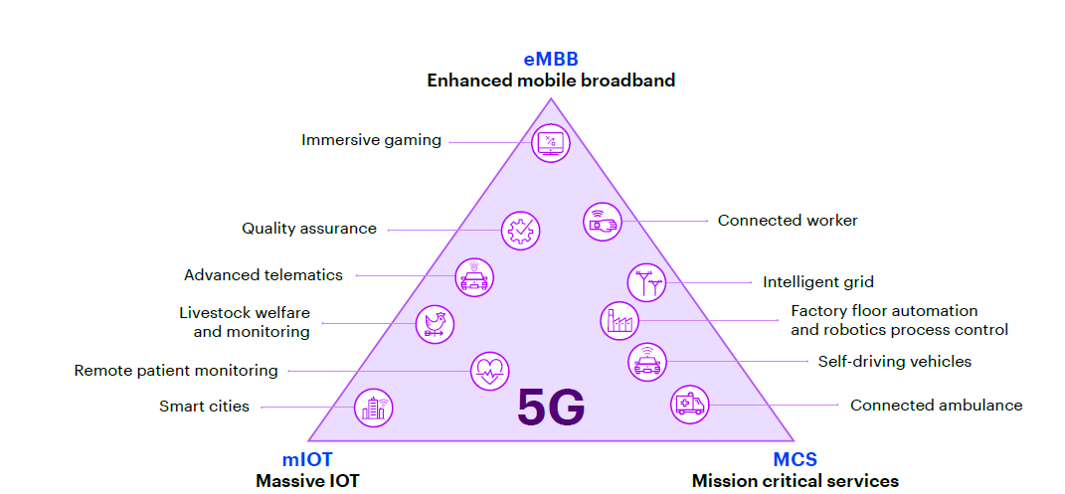
Figure 3: 5G key application areas, (source: The Impact of 5G on the European Economy, Accenture, February 2021)

5G across the world
In February 2021, there were 144 commercial 5G networks in more than 60 countries, while 413 operators in 131 countries / territories are investing in 5G networks in the form of tests, trials, pilots, planned and actual deployments. According to actual speed tests, the worldwide median download speed over 5G was indeed 10x faster than over 4G and the respective upload speed 3 times faster. At the end of December 2020, 5G commercial services had been deployed in 24 EU countries. In most countries, coverage is still limited but at least half of the EU-27 countries have succeeded more than 10% population coverage, with Finland already reaching 50% as of 2020 Q2.
Figure 4: 5G Coverage progress in Europe, Q2 2020 GSMA Intelligence

5G as a technology enabler
In 2026, 3.5 billion 5G subscriptions (excluding IoT connections) are forecast, accounting for 40 percent of all mobile subscriptions and, by 2023, more than 29 billion devices across the globe will be connected to the internet exchanging data in real time with half of them being machine-to-machine (M2M) connections. These devices include not only laptops, smartphones and TVs with which we are all familiar, but also a myriad of other smart connected objects: smart watches, glasses and wearables, package trackers, smart meters, smart fridges and windows, smart implants, drones, autonomous vehicles and robots in factories, construction sites and hospitals. Thus, mobile data traffic is expected to explode: Annual growth rate is expected to reach 26% for the period 2020-26 for Western Europe, and 5G networks are expected to carry more than half of the world’s mobile data traffic by 2026. 5G is expected to be a catalyst for the digital transformation of economies and societies enabling broad ecosystems of additional applications and use cases to emerge beyond what it seems possible today.
At the initial phase of 5G deployment, 5G services will focus on the consumer market with limited pre-commercial showcases of ultra-reliable use cases. Devices are expected to be similar to those already being used in 4G+, including smartphones, tables and portable gaming devices. However, as 5G evolves its full capabilities will significantly broaden the uses of 5G networks into multiple verticals with new applications enabled through end-to-end slicing (e.g. collaborative robots, automated machinery, autonomous transport) and new spectrum (incl. mmWave). In this context, 5G is not just a new technology but also an ecosystem, allowing new business models and innovation to spur and, eventually, transform the world. The fully integrated MNO model is likely to be complemented by sharing models (both at passive or active layers) or even wholesale ‘tower-operator’ models, driven by the need of economies of scale on network deployment costs. In terms of geographic scope, the country-wide operators are likely to be complemented by area operators (covering corporate campuses -i.e. airports, ports, large industrial plants, mining sites- or even smart-city level scales). Finally, network slicing is one of the key capabilities that will enable flexibility, as it allows multiple logical networks to be created on top of a common shared physical infrastructure. Network slicing will help to address the specific requirements of industrial vertical sectors (e.g. automotive, manufacturing, health) at the most efficient and timely way.
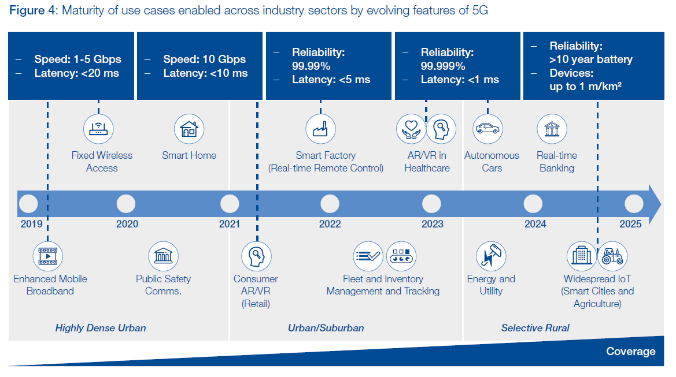
Figure 5: Maturity of use cases enabled across industry sectors by evolving features of 5G (source: The Impact of 5G: Creating New Value across Industries and Society, World Economic Forum, January 2020)

The deployment path of 5G
Some key concepts are of essence in order to understand the foreseen deployment path and evolution of 5G service capabilities:
5G will be deployed progressively, in two steps: Non-Stand-Alone (NSA) and Stand-Alone (SA). Firstly by introducing the 3GPP release 15 (New Radio, non-standalone - NSA) where 5G networks make use of the existing 4G core network. NSA 5G networks will utilise the existing 4G network core infrastructure, introducing new radio equipment on existing and potentially new macro-cells and will provide consumers primarily with enhanced mobile broadband (eMBB). Once 5G coverage is established and 5G use cases requiring machine-to-machine communication, ultra-low latency and much higher capacity emerge, MNOs will implement 5G NR standalone where the core network is entirely 5G. SA 5G networks require an entirely new architecture with virtualized network functions (NFV). NFV will allow MNOs to manage and expand their network capabilities on demand using virtual, software based applications instead of using hardware. While 5G NSA is already being deployed in most countries, only a few operators have confirmed 5G SA deployment by 2020 while most are expected to start SA deployment after a few years and it is expected that the two networks will coexist for several years.
5G will be progressively deployed on a wide range of spectral zones: 700 MHz and the 3.5 GHz bands will be deployed both for coverage and capacity (re-using the existing macro-cell sites), while the 26GHz band will be deployed in smaller areas, where very high demand is concentrated. In such cases, operators will need to deploy additional small-cell sites (i.e. to densify their existing macro-cell network and deploy road-side units along major highways). Some bands currently used for 3G and 4G are expected to be refarmed to 5G, as 3G will be phased out and 4G will serve smaller capacity needs. A deployment path that makes sense from a business perspective is depicted in Figure 6:
Figure 6: Potential deployment path to be followed by operators (source: “5G action plan review for Europe: final report”, Analysys Mason, 2020)
Private investments in 5G are expected to start from the more dense urban areas, by upgrading existing macro cells with 5G New Radio. As coverage becomes more widespread and 5G terminals cheaper, the take-up of 5G will increase, particularly if operators opt for a competitive pricing strategy. MNOs are expected to start 5G deployment from their existing macro-cells, and, in some extent, they will commonly use backhaul infrastructures or even co-invest. Progressively, as more and more people make use of 5G and data consumption increases, there will be a need for operators to densify their macro-cells networks by using small-cells covering areas with high concentration and progressively move to SA 5G networks.

Socio-economic impact
In terms of socio-economic impact, 5G networks, with their unprecedented increase in data transmission capacities, in the volume of connected devices and in real-time management capabilities thanks to their low latency, are set to be a key element in advancing the digital transformation of businesses, individuals, households and society. These transformations will have a direct impact on the creation of wealth and the economic development of the different states and regions.
An extensive list of reports and studies have identified economic, social and environmental benefits that can be materialized with the adoption of 5G technology in production, agriculture, transportation, and many other verticals:
- The global income from 5G will reach the equivalent of 247 billion € by 2025 and that the benefits of introducing 5G in four key industrial sectors for the EU, namely: automotive, health, transport, and energy, could reach 114 billion per year. 5G has the potential to contribute 8 trillion dollars to the world economy by 2030 and 13.2 trillion dollars by 2035 generating 22.3 million jobs in the global 5G value chain alone. Among the potential 5G use cases 55% will have a direct impact on health and welfare objectives and 40% on innovation and infrastructure objectives⁴⁴.
- In Europe, the cumulative additional GDP contribution of new digital technologies could amount to 2.2 trillion euros in the EU by 2030, a 14.1% increase over 2017. The impact of 5G on the European economy will drive up to €2.0 trillion in total new sales across all major industries in the European economy between 2021 and 2025. Over the same period, 5G will add up to €1.0 trillion to European GDP and has the potential to create or transform up to 20 million jobs across all sectors of the economy. Moreover, for every euro introduced by the direct effect of 5G in ICT, an additional €1.0 will be created elsewhere throughout the economy, for a multiplier effect of 2.0 on the total GDP.
- In Cyprus, it is estimated that by 2025, the introduction of 5G will be associated with 100 million euros investments, will have an induced impact of 470 million euros and an indirect impact of 950 million euros, as well as the creation of more than 20,000 jobs, Another study⁴⁶ estimates that it could add up to €2 billion to Cyprus’ GDP and has the potential to create or transform up to 20K jobs across all sectors of the economy.

European Union context
The European Union has adopted in recent years a number of policies and actions to facilitate the deployment of advanced networks infrastructures across the Union with the ultimate goal of a European Gigabit Society. The main policies of EU that are related to the context of the National Broadband Plan are the following:

Policies
European Gigabit Society: Through the Communication “Towards a European Gigabit Society” published in 2016, the European Commission confirmed the importance of Internet connectivity for the digital single market and the need for Europe to deploy the networks for its digital future. The Communication established a set of objectives for network deployment by 2025:
- All European households, rural or urban, will have access to Internet connectivity offering a downlink of at least 100 Mbps, upgradable to Gigabit speed.
- All urban areas and all major terrestrial transport paths to have uninterrupted 5G coverage.
- Gigabit connectivity for all main socio-economic drivers such as schools, transport hubs and main providers of public services as well as digitally intensive enterprises.
5G for Europe: An Action Plan: Through the Communication “5G for Europe: An Action Plan” published in 2016, the European Commission underlined the importance of very high capacity networks like 5G as a key asset for Europe to compete in the global market and defined specific actions in order for 5G deployment to be realized across Member States. It also defined that at least one major city in each Member State to be "5G enabled" by the end of 2020 and that all urban areas and major terrestrial transport paths have uninterrupted 5G coverage by 2025.
2030 Digital Compass: Through the Communication “2030 Digital Compass: the European way for the Digital Decade” published in March 2021, the European Commission envisions 2030’s European society as a digital society where none is left behind. It proposes to set up a Digital Compass to translate the EU’s digital ambitions for 2030 into concrete targets and to ensure that these objectives will be met. The Communication states that excellent and secure connectivity for everybody and everywhere in Europe is a prerequisite for a society in which every business and citizen can fully participate. The European Commission proposes that by 2030 all European households will be covered by a Gigabit network, with all populated areas covered by 5G.
Shaping Europe’s digital future: Through the Communication “Shaping Europe’s digital future” published in 2020, the European Commission defined as key priority the digital transformation of Europe for the benefit of all citizens through digital solutions that put the citizen at the forefront, create new business opportunities, strengthen an open and democratic society and contribute to sustainable economic growth. The objectives related to connectivity are the acceleration of investments in Gigabit infrastructure and the development of 5G corridors for connected and automated mobility on road and rail axes.
Connectivity Toolbox: Through the Connectivity Toolbox Recommendation published in 2020, the European Commission aims at fostering connectivity across the EU by (i) reducing the cost and increasing the speed of deploying VHCN and (ii) ensuring a timely and investment-friendly access to 5G radio spectrum. The European Commission called Member States to develop and agree on a common Union toolbox of best practices in order to reduce the cost of deploying very high capacity networks and ensure a timely and investment-friendly environment for 5G network deployment. In March 2021 the European Commission published the Connectivity Toolbox of best practices proposed by Member States to address the two main areas of reducing deployment costs and ensuring access to 5G radio spectrum.

Financing mechanisms
To promote the aforementioned initiatives, the European Union has set up different financing mechanisms. The main mechanisms are the following:
Recovery and Resilience Facility: The aim of the Recovery and Resilience Facility is to mitigate the economic and social impact of the coronavirus pandemic and make European economies and societies more sustainable, resilient and better prepared for the challenges and opportunities of the green and digital transitions. The Recovery and Resilience Facility will make €672.5 billion in loans and grants available to support reforms and investments undertaken by Member States. In order to foster the digital transition, 20% of the Recovery and Resilience Facility will be invested in related actions. Connectivity is among the flagship initiatives aiming to ensure comprehensive 5G and fibre coverage across Europe and to enable universal and affordable access to Gigabit connectivity in all urban and rural areas. The Total RRF amounts to 1.09 billion euros for Cyprus, with more than 200 million euros in digital projects, among which 52.5 million euros in digital connectivity projects.
Multi-annual Financial Framework: the MFF includes several mechanisms related with Broadband Infrastructure investments among which the most prominent are the Structural Funds (ERDF - Policy Objective 1: a more competitive and smarter Europe by promoting innovative and smart economic transformation and regional ICT connectivity, Specific Objective: v. enhancing digital connectivity) and the new Connecting Europe Facility programme (CEF2- Digital).
Connecting Europe Facility (CEF2 Digital) will fund very high capacity networks including 5G to ensure that the digital services and capabilities funded by the Digital Europe Programme are widely accessible across Europe. The budget proposed by the Commission amounts to €2 billion. CEF2 Digital will provide funding for:
- Cross-border 5G corridors along transport paths, including for connected and automated mobility.
- Gigabit connections for socio-economic drivers and 5G-ready communities: educational and medical centers; public buildings; business parks; households in surrounding areas.
- Key backbone connectivity networks of strategic importance, such as submarine cables, terabit-capacity connections for high performance computing and cross-border interconnections of European cloud infrastructures of strategic importance.

National context

Digital Strategy for Cyprus
The National Digital Strategy of Cyprus is the overarching policy of the National Broadband Plan. The goal of the strategy was to identify public interventions to achieve digital transformation of the public sector, the promotion of digital transformation of the private sector and the promotion of innovation. The vision of the Digital Strategy is:
“Cyprus to become a fit-for-the-future society and knowledge-based economy enabled by digital and emerging technologies that will drive economic prosperity and competitiveness to position the country as a resilient regional player in the European digital economy.”
The realization of this vision relies on achieving the following key objectives:
- Making technology work for people
- Creating a fair and competitive digital economy
- Creating an open, democratic and sustainable digital society
- Making Cyprus a resilient regional player with seamless business environment
The overall Digital Strategy is organised in a number of different portfolios:
- The Government as a Platform Portfolio, Digital Government Portfolio and Digital Infrastructure Portfolio with initiatives aimed predominantly at delivering the objective of Technology that works for people;
- The Digital Economy Portfolio with initiatives aimed at delivering the objectives of A fair and competitive digital economy, and making Cyprus a regional player with seamless business environment;
- The Digital Society Portfolio with initiatives aimed predominantly at delivering the objective of an open, democratic and sustainable digital society.
The Digital Infrastructure Portfolio aims at delivering the resilient, robust and secure infrastructure that will support Cyprus’ digital transformation enabling it to tap on the potential of frontier and emerging technologies. The programs under this portfolio aim at the creation of national digital identities and promotion of e-signatures, the establishment of a roadmap for the enhancement of national broadband (fixed and wireless), the development of a government cloud platform and cloud brokerage capability and better exploitation of national testbeds.
According to the Digital Strategy, the aim of the National Broadband Plan is to “enable Cyprus to achieve its national broadband objectives in alignment with the EU, increasing its Fibre to the Premises (FTTP) and 5G footprint, boosting the demand for very high capacity networks (VHCNs), promoting higher ultrafast broadband (at least 100Mbps) to achieve greater penetration especially in rural and suburban areas while reducing broadband prices”.

Electronic Communication services and the connectivity sector

Fixed
As of the end of 2020, state-owned incumbent Cyta holds the largest market share in fixed telephony, broadband and IPTV/CableTV, followed by Cablenet who is operating an alternative cable infrastructure, Primetel and EPIC. While in fixed telephony Cyta’s market share keeps eroding, in broadband and TV shares are rather stable with Cyta slowly decreasing until 2019, but slowly increasing in 2020.
Fixed Telephony | Broadband | IPTV/Cable TV
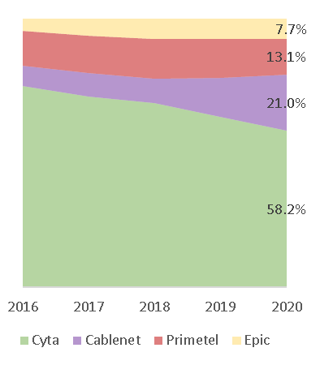 | 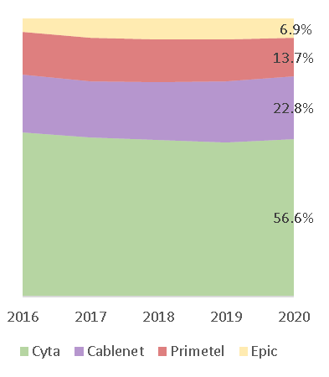 | 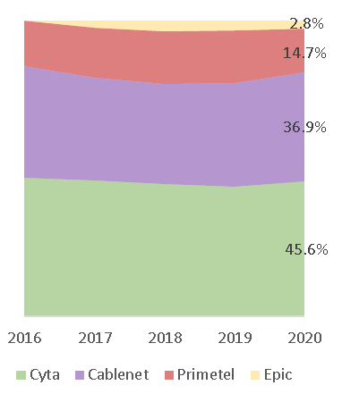
Figure 7: Market shares in Fixed Telephony, Broadband and IPTV/Cable TV
All players are active at both fixed and mobile markets providing a wide range of communication services combining fixed, broadband, mobile and TV services (with prime content, especially football) with a clear commercial strategy focusing on bundling. As a result, 88% of fixed broadband subscriptions are part of a bundle and around 40%, comprise three or four services, including a pay TV component. Given the importance of prime time content, two operators have agreed to exchange TV content.
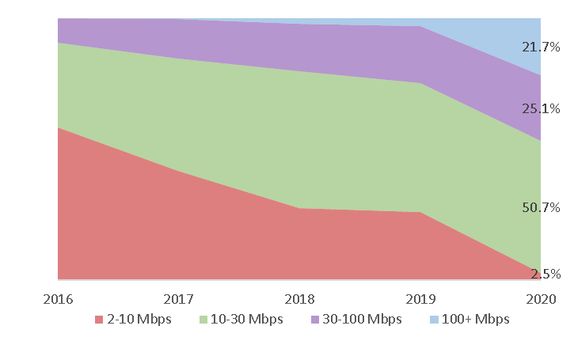  Figure 8:Evolution of Broadband subscribers by speeds | 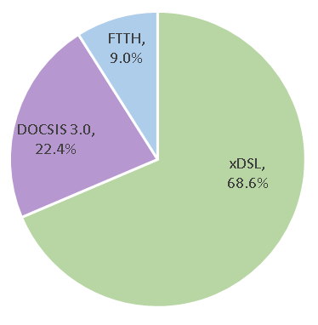  Figure 9: Subscribers by access technology
The broadband market in Cyprus is rather saturated as, according to the latest data, at the end of 2020 92.8% of Cypriot households have broadband connections with only 1.7% yearly growth. Based on the Broadband Coverage in Europe 2019 Survey, Cyprus achieved complete fixed broadband coverage at a national and rural level already in 2012 and by mid-2019 achieved comprehensive NGA coverage. Cable networks based on DOCSIS 3.0 were available in most urban areas, covering 55.5% of Cypriot households, but Cablenet has not launched DOCSIS 3.1, while it uses FTTH in the areas of new deployments.
The mix of fixed broadband subscribers by speed has naturally evolved towards higher speeds, particularly during the last year, as a combination of the increased availability of FTTH at affordable prices and the significant demand for higher bandwidth due to COVID lockdowns. The dominant access technology is xDSL followed by Cable and rather limited adoption of FTTH.
Cyprus is amongst the three most expensive countries in the EU, with fixed broadband prices considerably higher than the EU average. In baskets that include fixed broadband access the difference is relatively small at low speeds, but increases rapidly as the speed increases⁴⁸. This excessive price premium, negatively affected take-up of 100+ Mbps services. A pilot Voucher Scheme subsidizing the subscriptions of 100+ Mbps was implemented by the DEC during 2019-20 aimed to make prices more affordable. A 30% subsidy for a 12-month period with upper limit of 30 € per month was allocated to more than 3,000 users. Although the Scheme had a limited budget of 0.8 m€ and, thus, it could have no significant impact on take-up, it clearly showed that the excessive price premium for high speed broadband services is a major factor affecting demand and if lowered it could improve take-up.
It should be noted that, in 2020, there was a considerable decrease in prices for fiber-based services charged by the incumbent. It is noticeable that prices for similar speeds offered on FTTH are much lower than the ones offered on VDSL, providing strong incentive for the transition from copper to fiber.

Mobile
Mobile market is duopolistic, with the two largest operators (Cyta and EPIC) having a combined market share close to 90%, followed by Primetel and Cablenet.
Mobile Telephony | Mobile Broadband
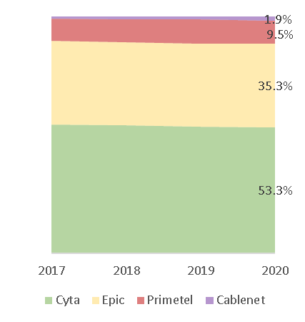 | 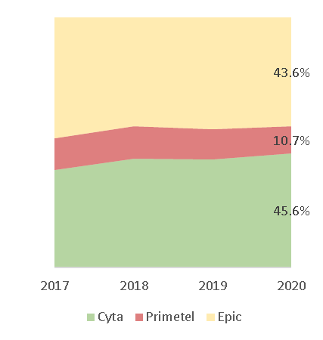
Figure 10: Market shares in Mobile Telephony and Broadband

Mobile coverage through 4G is available to 99.6% of the population (96.6% in rural areas). Cyprus significantly outperforms the EU on mobile broadband penetration (117 subscriptions per 100 people versus the EU average of 100). Cyprus is amongst the three most expensive countries in the EU, with mobile broadband prices considerably higher than the EU average⁵⁰. Cyprus ranks 27th with the least expensive offers being much higher than the EU average and no offers found to be less expensive than the EU average. Recent developments
In 2018, Cyta announced a ten-year €100 million investment plan to cover 200.000 premises with FTTH. Following Cyta’s announcement, all three operators expressed interest in co-investments, but discussions did not lead to any agreement. In 2019, Cyta, started to deploy a G-PON fibre-to-the-home (FTTH) network aiming to complete 60% of the project within 4 years. According to a recent announcement, the implementation timeframe was considerably reduced and the 200.000 premises target is expected to be completed by 2023. Cyta already offers, through both retail and wholesale, a range of services with speeds up to 1 Gbps. After the conclusion of the spectrum auction, Cyta announced that population coverage of its 5G network already reaches 70% and will reach 98% within a year.
Cablenet has announced that all new installations will be fibre-based. It deployed a FTTH access network in Dali-a suburb of Nicosia- and is currently deploying in Pafos (2020). Apart from the 5G spectrum, Cablenet who already operated as MVNO with an agreement with Cyta, obtained in 2019 a new mobile license by auction.
EPIC deployed a pilot FTTH project in Akropolis and plans to deploy their own extensive fibre network. Epic recently assured a 19 m€ loan from EIB to develop a 1.600Km fiber network to offer FTTH services in urban and rural areas. EPIC recently transferred the ownership of its 100% subsidiary of mobile infrastructure management ‘M.T. Mediterranean Towers Limited’ to ‘Phoenix Towers International’ to enforce EPIC’s investment plan for the modernization of its mobile network to 5G and the deployment of FTTH.
In December 2020, Cyprus concluded the 5G spectrum auction of 700 MHz and 3.5 GHz bands, which resulted in the allocation of all available spectrum to 4 bidders raising 41,6 M€. The spectrum allocated per MNO is depicted in the following table:
Spectral zone | Allocated spectrum | Cyta | EPIC | Cablenet | Primetel
700 MHz | 2 x 30 MHz | 2 x 10 MHz | 2 x 10 MHz | 2 x 5 MHz | 2 x 5 MHz
3.6 GHz | 400 MHz | 100 MHz | 100 MHz | 100 MHz | 100 MHz
Spectrum assignees will have to meet specific coverage requirements as follows:
70% of the population of the Republic of Cyprus as well as all highways and main roads, should be covered by 31/12/2025. The acceptable signal level should assure that the end-user will be able to satisfactorily receive the basic electronic communication services that will be provided by 5G networks (e.g. speed of 100 Mbps). In case it is deemed necessary, DEC will define (after consultation with the spectrum assignees) a specific signal level.

Cyprus and cross-border connectivity infrastructures
Cyprus due to its key position in the East Mediterranean is often a landing point of submarine cable systems either for technical reasons (rebirth of optical signals) or for interconnection and data exchange between different cable systems. There are 19 submarine cable routes (including lease agreements) that connect Cyprus with various destinations in Europe and Middle East corresponding to 10 actually installed cable systems. However, it seems that the installed capacity of the existing submarine cable systems is not sufficient to support the increasing needs of Cyprus and the broader region in the long-term. Moreover, the two submarine cable systems interconnecting Cyprus and Greece (Crete) were deployed in 1999 and 2001, and therefore, are very close to their useful life limit of 25 years.
Cyta recently announced the construction of Arsinoe submarine system. The system consists of a new cable from Yeroskipos to a branching unit of the Peace submarine cable, through which it will obtain access to France and Egypt. The commercial launch of the system is expected in 2022Q1.
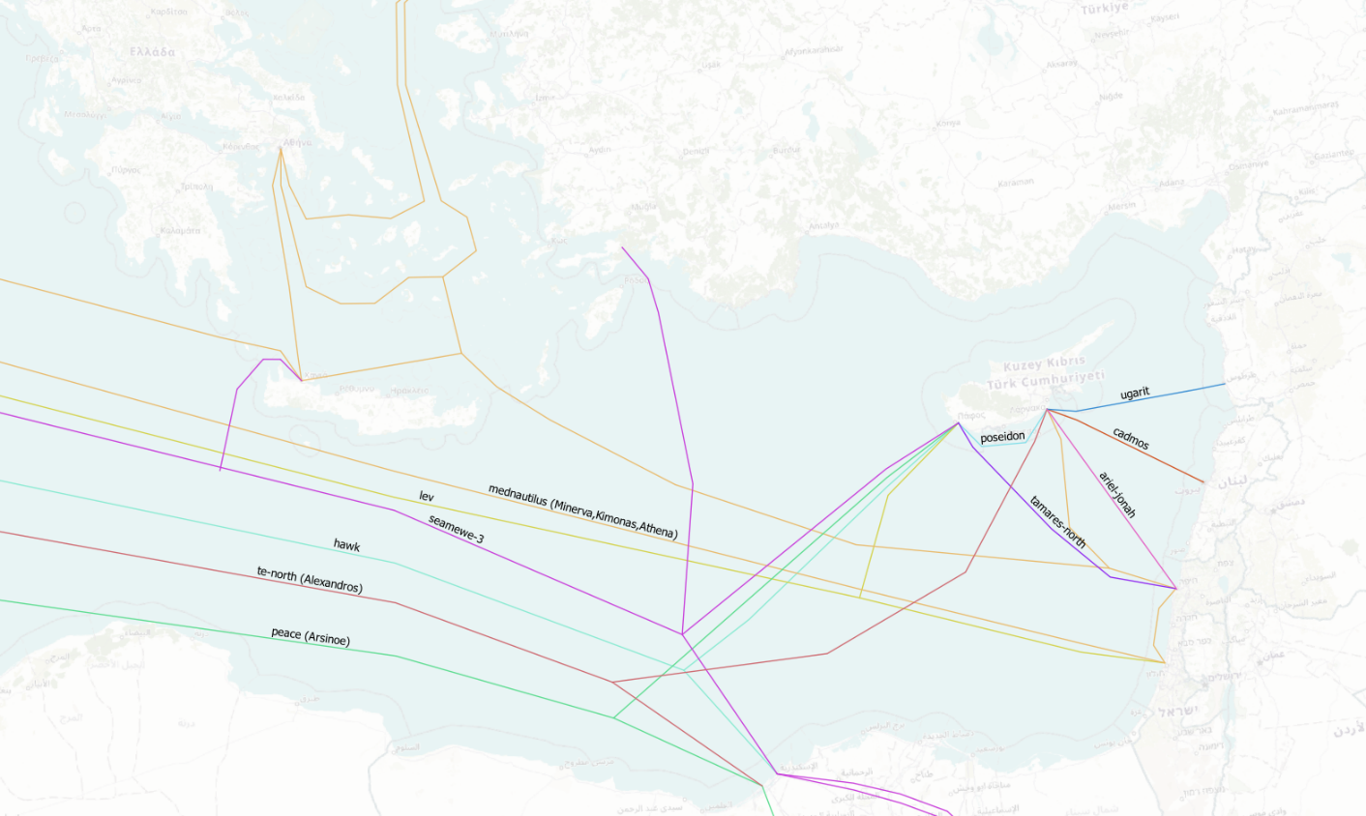
Figure 11: Submarine cable systems landing in Cyprus (source: Enomix analysis based on data from various sources)

Satellite facilities in Cyprus
Cyprus, due to its privileged geographical position, is a suitable place for providing teleport services to major satellite communications service providers. It combines excellent climatic conditions ideal for satellite communications (extensive sunshine, low rainfall and mild temperatures) with an optimum visibility of the geostationary arc covering any satellite location between 33,5°W and 100,5°E. Therefore, teleports in Cyprus can reach satellites with coverage ranging from the Americas to Australia and can be used for a wide number of services (satellite television broadcasting and turnaround, internet connectivity and hosting services, VSAT links and satellite control & monitoring services). Due to Cyprus’ proximity to a number of submarine cable systems, teleports can also be used to provide integrated solutions that combine fibre-based and satellite communications. There are four satellite teleports located in Cyprus. Three of them (Makarios, Pera and Ermis) are operated by Cyta and host more than 40 major satellite earth stations and 100 Rx antennas. Makarios was recently Tier 4-certified by the World Teleport Association. The fourth teleport is operated by Hellas-sat which, also, operates the Hellas Sat 3 and 4 satellites located at 39°E.

Data centres
Cyprus holds a privileged geographical position in the East Mediteranean making it a suitable place for deploying data center infrastructure covering not only Cyprus’ needs but also the extended region. There are 16 colocation data centers in 7 different areas. The two cities with the higher number of data centers are Nicosia with 7 data centers and Limassol with 4. Services being provided through these data centers include web hosting, colocation, application hosting and management, data backup and disaster recovery, business continuity as well as a range of cloud services, including Infrastructure as a Service (IaaS), Software as a Service (SaaS).
Cyprus ranks 85th globally based on the data center density, lagging behind other countries of the extended region, like Egypt (67th), Israel (65th), Greece (55th) and Bulgaria (41th). The most important Internet hub in the broader region in terms of international capacity is Istanbul which ranks 16th globally, followed by Sofia (19th).

DESI connectivity ranking
Cyprus is constantly progressing in all dimensions of the Digital Economy and Society Index (DESI) and ranks 23rd out of the 27 EU Member States for year 2020, having lost 2 positions from 2016 when it ranked 21st. It is lagging behind in all DESI dimensions with poor performance particularly in connectivity and human capital.
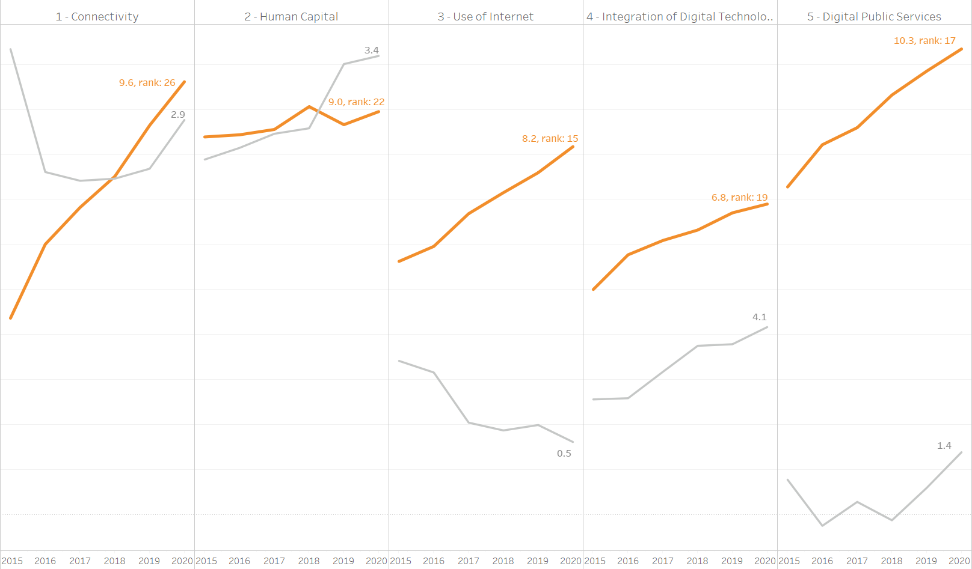
Figure 12: Evolution of Cyprus performance in DESI dimensions (orange line) and distance from EU average (grey line) (source: Enomix analysis based on The Digital Economy and Society Index (DESI) dataset)
More specifically, in DESI connectivity dimension, Cyprus ranks 26th for 2020, with increased distance from the EU average compared to 2019. Cyprus displays a rather bipolar picture and specifically:
- top performer for fixed broadband take-up, fast broadband (NGA) coverage and 4G coverage
- very good ranking for 5G readiness and mobile broadband take-up
- lagging seriously behind in VHCN coverage, take-up of at least 100 Mbps services and Broadband prices. Figure 12 depicts the comparative performance of Cyprus in the various indicators of the connectivity dimension of DESI:
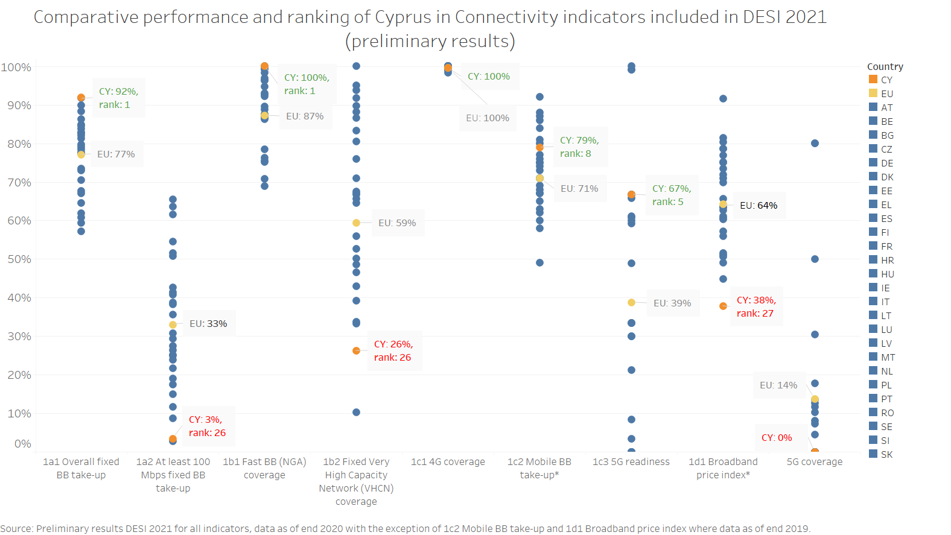
Figure 13: Cyprus performance in the indicators of DESI connectivity dimension (source: Enomix analysis based on The Digital Economy and Society Index (DESI) dataset)⁴⁹

Assessment of the current state
While drafting the National Broadband Plan a number of formal and informal consultations with stakeholders took place in order to identify the most appropriate and effective public interventions to address challenges and market failures.

Mapping of private investment plans
The purpose of the mapping was to get an insight on private investment plans for the deployment of broadband infrastructures, in order to identify areas that are expected to remain uncovered by VHCN by 2025. In this context, in July 2020 (with a later update in January 2021), OCECPR requested all network operators to submit their investment plans, identifying -in geographical terms- the coverage of their current and future networks, as well as the expected broadband service speeds that would be delivered. All four operators submitted detailed information regarding their expansion plans in fixed networks, which were subsequently analysed to define the areas expected to remain uncovered by VHCN. Figure 14 shows the areas where private investment plans are expected (and those where they are not expected) to provide download speeds of at least 100Mbps, readily upgradable to 1 Gbps. It is noted that there are sub-areas where more than one network capable of providing download speeds of at least 100Mbps, readily upgradable to 1 Gbps are to be deployed.
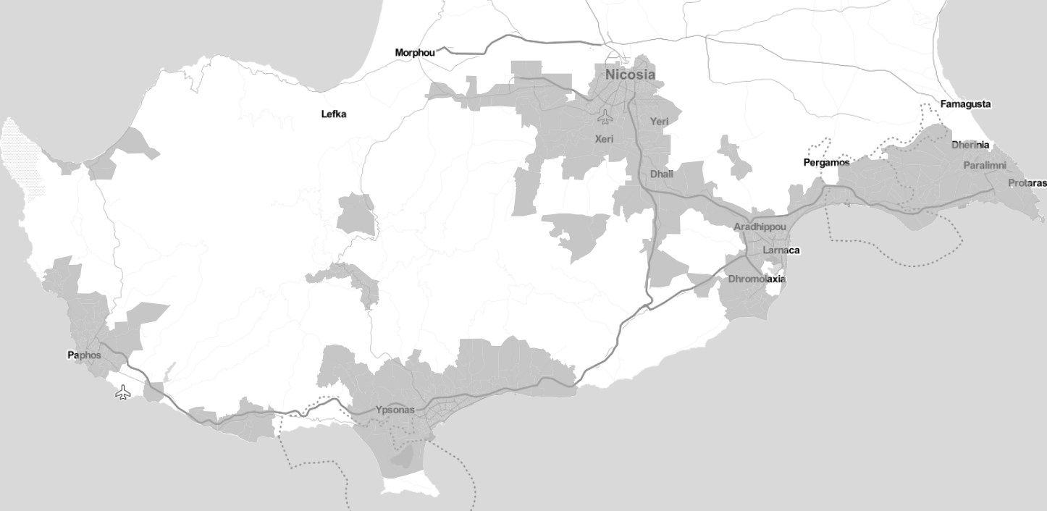
Figure 14: Estimated coverage by fixed VHCN networks by 2025 (grey denotes areas expected to be covered with download speeds of at least 100Mbps, readily upgradable to 1 Gbps) (source: Enomix analysis based on data from private investment plans)
Based on the analysis, there are 311 tele-regions (out of 1176), serving 31,900 subscriber lines (out of 309525) or 10.3% of the total subscriber lines. It is estimated that this corresponds to 42,975 premises,,.
Given that, the information regarding 5G coverage was requested shortly after the spectrum auction, only two operators (Cyta and EPIC) provided detailed geographical information. Although Cyta was not able to provide a 5G coverage map, it provided the base stations where it has no intention to install 5G equipment by 2025, based on which, a 5G coverage map was simulated. Figure 15 illustrates the combined estimated 5G coverage by both operators and the residential areas that are expected to remain fully or partially without 5G coverage and corresponds to 21,860 people living in 159 residential areas.
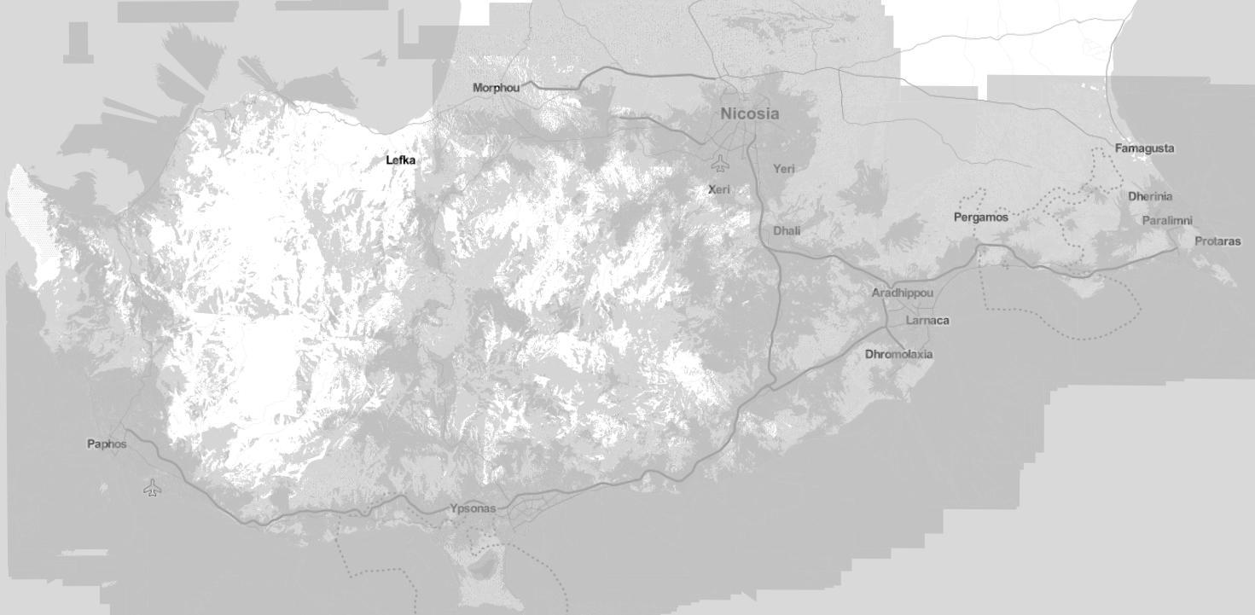
Figure 15: Estimated coverage with 5G networks through private investments by 2025 (source: Enomix analysis based on data from private investment plans)

Consultation on Connectivity roadmap
In March 2021, the European Commission published the Connectivity Toolbox⁵³ of best practices proposed by Member States to address the two main areas of reducing deployment costs and ensuring access to 5G radio spectrum. The toolbox is the main outcome of the Connectivity Toolbox Recommendation⁵⁴ published in 2020.
By 30 April 2021, member states should have developed a national roadmap for the implementation of the Toolbox. According to the Recommendation, member states make use of the commonly agreed Connectivity Toolbox to the utmost extent, while selecting or adapting proposed measures, where necessary, according to national circumstances. In order for Cyprus to assess and decide on the implementation of the specific best practices included in the toolbox, it was considered appropriate to consult with the network operators requesting their views on the effectiveness of each proposed best practice in Cyprus. The results of the consultation were taken into account in developing the national roadmap.

5G opportunities and benefits for Cyprus beyond commercial deployments and eMBB
In the first years of 5G deployment, the main (if not the only) driver for commercial deployment will be Consumers’ need for very fast speeds (i.e. Enhanced Mobile Broadband (eMBB)). Progressively more advanced business-oriented solutions will emerge, targeted to specific needs of the local economy and key vertical sectors, by exploiting Massive Machine Type Communication (mMTC) and Ultra-Reliable and Low-Latency Communication (URLLC) aspects of 5G. Some use cases (i.e. Smart Factories, Airports, Ports etc) are expected to be market–driven, i.e. the incremental cost to upgrade/densify the 5G network in those particular areas in order to support such services, will be borne by the beneficiaries of those services (i.e. Industries, Airport/Port Operators etc). Other use cases might require public funding in order to be enabled (i.e. Healthcare and hospitals, Smart automotive, Agriculture etc). To identify the benefits of 5G deployment beyond eMBB for Cyprus, we exploit the results of the study “5G action plan review for Europe: final report”, which:
- At first, identifies a series of use cases that can benefit from 5G, across various clusters of the economy, and provides a quantitative estimate of social, environmental and economic benefits, while also assessing the costs, beyond those that an MNO will typically incur (e.g. the incremental cost to enable the use case over and above the cost that the MNO will incur).
- Then, it identifies the use cases that will be market-driven and those that might require public funding (e.g. a smart factory use case will be market-driven, while healthcare provision to remote villages might require public funding) and,
- Finally, it takes into account the structure of EU countries’ economies to estimate the CBR for each cluster of use cases for each country (e.g. a highly industrialised economy can reap higher benefits from the smart factory use case compared to a services-oriented economy)
The results of the above study are summarized below (see Figure 16):
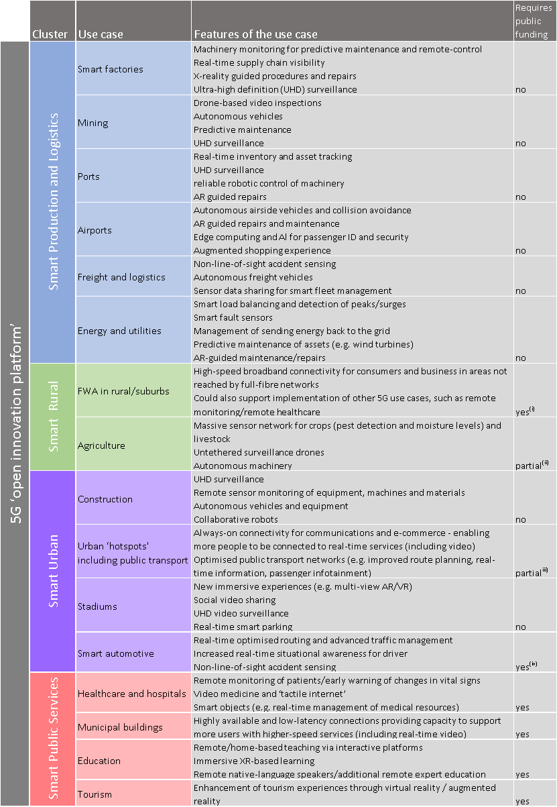
Figure 16: Use cases that can benefit from 5G beyond eMBB (source: 5G action plan review for Europe: final report, Analysys Mason)
Based on a quantitative cost-benefit analysis, the study estimates that across EU, as a total ‘open innovation platform’, full 5G networks can deliver over 208 billion € benefit, at 46 billion € cost (i.e. a 4.5x ratio additional benefit vs cost). The incremental cost, benefit and the CBR of each use case across EU are depicted in Figure 17.
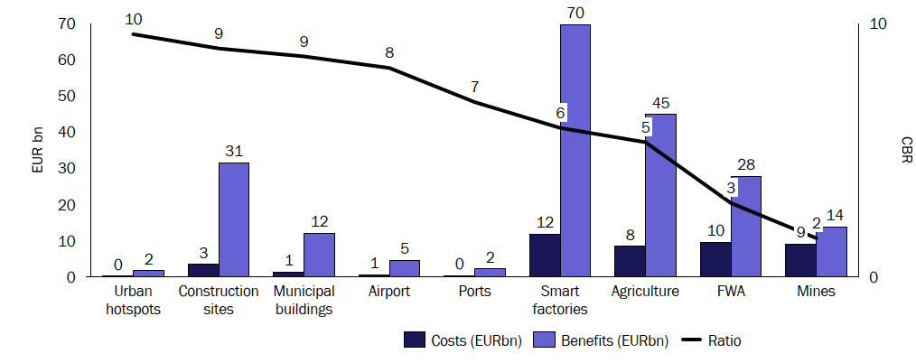
Figure 17: 5G cost, benefit and cost–benefit ratio (CBR) across EU (source: 5G action plan review for Europe: final report, Analysys Mason
For Cyprus, the cost, benefit and CBR per cluster are depicted in Table 1.
Cluster | Incremental Costs (m€) | Benefits (m€) | CBR
Smart Production | 20 | 57 | 2.9
Smart Rural | 15 | 190 | 12.3
Smart Urban | 12 | 82 | 6.9
Smart Public Sector | 12 | 30 | 2.5
Table 1: Cost, benefit and CBR of 5G use cases for Cyprus (source: 5G action plan review for Europe: final report, Analysys Mason
The clusters with the higher CBR for Cyprus are ‘smart rural’ and ‘smart urban’. To gain a better insight, we illustrate in Figure 18, the Cyprus CBR per cluster (red) with respect to the CBR per cluster of all other EU countries (blue). It is evident that Cyprus has the most to gain from 5G (with respect to other EU countries) in those particular clusters.
Some important notes:
- Smart Production (all use-cases): As noted in the study, ‘Smart factories are nearly always the largest component of the total benefit’. Given that deployments in this cluster are market-driven (backed up by strong vertical market players) we believe that no actions in this respect are recommended for public intervention.
- Smart Rural (FWA in rural/suburbs): As noted in the study, ‘the results for the Smart Rural cluster are driven by low levels of FTTP’ (meaning more FWA benefits from take-up). The study has estimated a 5% of the broadband market to be covered by FWA deployment. Taking into account that comprehensive NGA coverage is already offered -see chapter 4.2.1- we believe that this potential is overestimated. In any case, the public intervention to cover underserved areas –see chapter 4.4.1- will fully respect the principle of technological neutrality.
Figure 18: Cost Benefit Ratio of 5G for various use cases for Cyprus (source: Enomix analysis based on “5G action plan review for Europe: final report” 2020, Analysys)
- Smart Rural (Agriculture): Agriculture in Cyprus, in terms of GDP participation (2%) is slightly above EU average (1.8%), although the share of utilized agricultural area (12%) is among the smallest (EU average 39%). Smart irrigation in Cyprus’ environmental conditions, combined with the water scarcity, is associated with significant benefits that could not have been captured in the study. It is therefore recommended to expedite 5G coverage of the agricultural areas that are expected to remain uncovered by private 5G investment plans -see chapter 4.4.1.
- Smart Urban (Construction, Stadiums): As noted in the study, ‘The aggregate benefit within the Smart Urban cluster for a given country is overwhelmingly derived from construction sites’. Construction in Cyprus, in terms of GDP participation (6.4%) is above EU average (5.5%)⁸¹. Given that deployments in this cluster are market-driven, no actions in this respect are recommended for public intervention.
- Smart Urban (Smart automotive): Although the potential environmental benefits are potentially high and public intervention might be required (e.g. 5G corridors promoted by CEF2), the use case is focused on high-traffic transportation corridors that are irrelevant for Cyprus, and therefore, no actions in this respect are recommended for public intervention.
- Smart Urban (Urban ‘hot spots’ including public transport): As noted in the study ‘The urban hotspots use case is assumed to include provision of connectivity for public transport in urban areas (e.g. for provision of real time passenger and other travel/tourist information). The public-transport portion of the cost associated with this use case (estimated to be around 10%) would require public funding.’ It is recommended to expedite 5G coverage of such urban hot spots (i.e. bus terminals), particularly in cases where commercial coverage proves to be weak.
- Smart public services: Although all use cases would require public funding, the associated CBR is the lowest among all clusters for Cyprus. It would therefore make sense to prioritise the most important public services buildings/locations (Healthcare and hospitals, Municipal buildings, Education and Tourism) in order to increase the CBR, given that for such cases, similar costs are associated with increased benefits. It is therefore recommended to focus public funding only to large Hospitals and complexes of multiple Municipal buildings, particularly in cases where commercial coverage proves to be weak.

Diagnosis
In order to diagnose the status in Cyprus as regards connectivity and to identify possible areas for public intervention, a SWOT analysis is an appropriate tool:

Strengths
Cyprus has some strong points that can be the foundation of the connectivity policy:
- Political commitment for the digital transition with consolidated competencies in the newly established Deputy Ministry of Research, Innovation and Digital Policy (DMRID)
The digital transition of Cyprus is a key priority of the Government and there is the necessary political commitment at the highest level as it is evident by the establishment of the DMRID which consolidates all the relevant competencies.
- The structure of the economy as an international service center and the relatively high contribution of the financial and tourism sectors that are already adopting actions towards the digital transition
Cyprus is a service-oriented economy that offers services worldwide. The financial and tourism sectors are key economic sectors in Cyprus with high contribution in the overall economy. These sectors are in a phase of digital transformation and, thus, require reliable ultra-fast broadband services.
- Small size of the country with close co-operation between the state and the economy that allows the implementation of horizontal policy interventions
Cyprus is a relatively small country with a well-performed institutional framework and close co-operation between the central government and the economy that allow the design and implementation of horizontal policy interventions that bring immediate benefits to the society.
- Cyprus’ key position in the SE Mediterranean for fibre-optic submarine networks and satellite teleports
Cyprus holds a key position in SE Mediterranean which is an important route for international cable systems. Moreover, Cyprus is a suitable place for installing satellite teleports.
- Investment-friendly environment (taxation, administrative procedures)
Cyprus is an attractive investment destination as it is among the most investment-friendly states worldwide due to its taxation system, low administrative barriers and friendly legislation.

Opportunities
The successful implementation of the National Broadband Plan will significantly improve the network infrastructures of Cyprus and increase the take-up of ultrafast broadband enabling the digital transition of economy and society:
- Strengthening the position of Cyprus as an important hub for international internet traffic exchange at regional level
The SE Mediterranean is an important route for international cable systems interconnecting Asia and North Africa with major data exchanges in Europe. Cyprus could further exploit its key position in the region so that it becomes an important hub for international internet traffic exchange at regional level providing alternative routes.
- Attracting data center infrastructure and satellite teleports
Cyprus could attract data center, colocation and cloud service providers providing services not only in Cyprus but, also, in the extended region due to its key position in the East Mediterranean. Cyprus could also attract investments in satellite teleports providing broadcasting services in the East Mediterranean and Middle East region.
- Attracting digital nomads
Cyprus could become an ideal home for high-skilled and talented people from all over the world that choose to work as digital nomads living in countries with advanced network infrastructures and high quality of life.
- Full coverage with ultra-high speed networks (VHCN) is feasible by 2025 as a combined result of ambitious private investment plans and targeted public intervention
Full coverage of Cyprus can be realized within the defined timeframe as a combined result of ambitious private investment plans already in place and targeted public intervention aiming at bridging the investment gap.

Weaknesses
Despite its strengths, Cyprus has also some weaknesses that might affect its ability to succeed in the implementation of its policy:
- Low digital skills of citizens
A large proportion of Cypriots lack basic digital skills that are essential to actively participate in the digital world. This might affect demand for ultrafast broadband services.
- High prices of retail broadband services
Cyprus ranks at the very bottom between other European countries as regards broadband prices. High prices constitute a major obstacle for citizens and businesses to get advanced broadband services. This is more evident in the case of broadband services provided over the copper network, which can nevertheless be considered as an opportunity, since it will help for the migration towards FTTH services which are offered at much lower prices.
- High costs of international interconnection
Cyprus lacks sufficient international interconnection links and, thus, prices for international capacity are higher than in other European countries. This also affects the price levels of broadband services.
- Outside of urban areas, electronic communications market is characterised by low level of competition with a dominant incumbent operator
Although in urban areas there is both infrastructure and services competition, outside urban areas the market is characterized by relatively high market shares of the incumbent operator and lack of interest for investments by other operators. Market dynamics should be closely monitored in order to address market failures that could possibly affect the success of national policies.
- The regulatory framework to facilitate VHCN deployment and reduce the relevant costs can be significantly improved
(transparency of information, , scaling-automation of use of existing infrastructure, etc.)

Threats
The successful implementation of the National Broadband Plan and the achievement of its objectives could be threatened by external factors that should be taken into account in design of the proposed actions and be monitored during the implementation period:
- Delay or cancellation of alternative providers’ investment plans for VHCN deployment may lead to re-monopolization of VHC network
Deployment of VHC networks by alternative operators is essential for infrastructure-based competition to be developed in Cyprus. Any delay or cancellation of alternative providers’ investment plans very likely would lead to re-monopolization of the VHC network in favor of the incumbent.
- Competition from other countries in attracting investments in network and data center infrastructure
Other countries in the region might also adopt policies in order to attract investments in network infrastructure and data centers and this could affect Cyprus’ success in this regard.
- Delays in the implementation of submarine cables
Implementation of international submarine cable systems is a long and complex procedure that requires detailed study and environmental permissions that could impose significant delays. Timely implementation could also be threatened by geopolitical factors.

Vision, objectives and targets
Cyprus sets a vision:

"To perform a leap in digital connectivity by 2025, so as to enable the digital transition of the society and economy and to strengthen its role as regional data gateway for the EU"

In this context, it adopts the following objectives:

Objective A: Promote private investments as much as possible, remove administrative barriers and encourage stakeholders’ co-operation
Objective B: Ensure comprehensive availability and the widest adoption of ultrafast broadband services

In this regard, it sets the following connectivity targets, to be achieved by 2025:

1. Gigabit connectivity for all main socio-economic drivers
2. All premises in organized communities (urban or rural) to have access to internet connectivity offering a download speed of at least 100Mbps, which can be readily upgradable to 1 Gbps
3. 100% of the population living in organized communities (urban or rural), and all major terrestrial transport paths to have uninterrupted 5G coverage with a download speed of at least 100 Mbps
4. 70% of households to have an internet connection (take-up) with a download speed of at least 100Mbps

Actions
The National Broadband Plan includes an extensive list of actions organized under its two objectives:

Objective A: Promote private investments as much as possible, remove administrative barriers and encourage stakeholders’ co-operation
In order to achieve objective A, several actions need to be performed, including the re-assessment and reform of certain provisions of national legislation and administrative procedures. OCECPR and DEC will assume the responsibility for the coordination of all involved stakeholders (such as ECN operators, permit granting authorities, ministries and other utilities) in order to undertake the steps required towards the implementation of each respective actions. The Connectivity Toolbox⁵⁴ is an extended list of best practices to address the two main areas of reducing deployment costs and ensuring access to 5G radio spectrum. In accordance with the Connectivity Toolbox provisions, Cyprus submitted on April 2021 a roadmap towards its implementation, after having consulted with the market. The main actions of the roadmap are included below (with reference to the respective Best Practice of the Connectivity Toolbox). Some further additional actions are also included.

A1. Introduce permit exemptions and fast track procedures and promote the application of existing lighter permit granting procedures (BP-1)
Cyprus plans to reduce administrative burden and speed up the deployment of ECN infrastructure:
Regarding towers/masts, there is an initiative for a new Order regarding planning permits for radio communication stations. This Order will consider that the permission has been granted by the Planning Authority, for the construction of a radio communication station with broadcasting capability, provided that the following apply:
- The station is installed on the roof of a building with a height equal to or greater than the maximum allowed building height in the respective Urban Zone, or
- The station is installed on the roof of a building with a height less than the maximum allowed building height in the respective Urban Zone, even if in the same area and at a distance of less than 200m from the site of the station, there are or are allowed to build taller buildings, when the direction of radio wave transmission is documented to allow it or when the radio station is of the "micro" type as defined in Order 3 of 2006 of the Minister of Interior, or
- The station is installed on the ground, in an area that does not fall within a defined development area, and the height of the tower / mast does not exceed 25m.
The implementation of the order is highly dependent on the legislation, procedures and policies of public authorities. It is noted that small-area wireless access points are exempted as per Regulation (EU) 2020/1070.
Regarding other infrastructures, the following approach will be used:

- Identify if national legislation provides permit granting authorities to use exemptions or notification mechanisms at their discretion
- Identification if any and what types of the ECN deployments could be subject to a lighter permit granting regime or be exempted from a prior permit request on the grounds that their impact on aspects of public interest can be presumed to be minimal.
- Identify any possible criteria related to exemptions or lighter permit procedure.
- Review relevant national legislations, policy frameworks, codes of practice.
- Proposal to include this BP in a policy paper as a transitional measure

A2. Provide model regulations on electronic communications network deployment (BP-2)
The expected plan is to review the existing framework (model provision) and update it accordingly to describe fast-track procedures or other lighter permit mechanisms in relation to the outcome of the BP-1. It will further be scrutinized regarding its clarity, to assure consistent application across the different local authorities, which will be also promoted through the actions of BP-3.

A3. Provide informative materials and workshops for municipalities and other competent authorities (BP-3)
Despite the fact that there is an established procedure that streamlines permit granting, informative material will be further reviewed as a complementary measure. Therefore, the expected plan is to:
- Identify the relevant entities for the production/review of informative materials based on competency.
- Identify the best suited material to be provided.
- Review existing informative material.
- Production of new informative material if required.

A4. Digital administrative portal/single information point (SIP) coordination (BP-5)
OCECPR (National Regulatory Authority) coordinates the whole procedure for permit granting for ECN (for fixed wired network infrastructures only) and has developed an electronic permit application system for the deployment of fixed infrastructures which is gradually released per Municipality/District. The expected plan is to formulate the necessary policy decisions to enforce the system use and to enroll all the required users. Regarding infrastructures for mobile networks, only the notification part of the process is currently performed electronically. The inclusion of the whole procedure within the above mention system, will be assessed within the context of the current BP.

A5. Ensure the availability of information from different sources and enhance transparency of planned civil works (BP-11)
The OCECPR will implement an action for the upgrade of the infrastructure registry, which includes passive infrastructures of electronic communications providers and other network operators, available for Very High Capacity network deployment. Such infrastructure includes pipes, , masts, poles and manholes that can host equipment. The registry will include existing as well as planned infrastructure and will be regularly updated. The relevant information will be available in electronic format by all stakeholders taking into account certain confidentiality restrictions. The action, also, includes the implementation of a broadband coverage map, which will provide citizens and businesses all the necessary information as regards the type of services provided in a specific area, the available speeds and how to get access to these services.
Consequently, this unified web portal system will enable the integrated production and provision of data on the reach of broadband networks and network infrastructure according to the requirements of OCECPR and the provisions of the following Legislative proposals:
- Article 22 of the Directive (EU) 2018/1972 of the European Parliament and of the Council of 11 December 2018 and BEREC Guidelines on Geographical surveys of network deployments BoR 20(42) which will be applied through secondary legislation (OCECPR Decision).
- Directive 2014/61/EU of the European Parliament and of the Council of 15 May 2014 on measures to reduce the cost of deploying high-speed electronic communications networks.
This action will also take into consideration the impact assessment for the required investment by ECN operators to digitalise their networks and create web services (where these are not available).
Within the context of this action BP-12, 13 and 14 will also be implemented, (ie. BP-12. Ensure the availability of information via the Single Information Point (SIP) in electronic format, BP-13. Include Georeferenced information (maps and digital models) in the data made available via the SIP and BP-14. Make available indicative information on the occupation level of the infrastructure and/or the existence of dark fibre. At the present all electronic available information of Physical Infrastructures is available to ECN operators which is mainly information on Physical Infrastructures of ECN Operators that covers basic information as proposed in the Broadband Cost Reduction Directive.

A6. Ensure access to physical infrastructure controlled by public bodies (BP-16)
The implementation of this BP is highly dependent on the current legislation, procedures and policies of public bodies. The introduction of this BP will be consulted with the potential stakeholders. The expected plan includes:
- Identify if national legislation, allows access to Physical Infrastructure owned or controlled by public bodies.
- Identify any exceptions.
- Review relevant national legislations, policy frameworks, codes of practice.
- Proposal to include this BP in a policy paper as a transitional measure.
Within the context of this action, BP-17.Entrust a body with a coordinator and/or promoter role, as well as BP-18. Development of guidelines for all governance levels will also be implemented.

A7. Timely availability of 5G harmonised bands (BP-25)
In Q4 2022 the DEC plans to conduct a public consultation and if there is market demand to proceed with the authorisation of the 26 GHz band. In the context of the current action BP-28. Individual authorisation regime for the 24.25-27.5 GHz frequency band will also be implemented, including in the public consultation the possibility of a flexible authorisation with a focus on local licensing and infrastructure sharing.

A8. Coordinated and targeted communication for informing and educating on 5G implementation (BP-38)
The plan is to provide evidence-based information to specific groups and to educate the wider public about 5G thus strengthening public confidence in institutions, which in turn may increase acceptance for the new 5G technology. Currently a comprehensive information campaign is taking place, in cooperation with the ECN operators and all relevant competent authorities. The main goal is everyone to be informed for the benefits of 5G. This campaign is led by the DMIRD, and targets the members of the government and parliament, the local authorities and the general public. This campaign includes TV and radio spots, informative leaflets, billboards, which point out the benefits of 5G. Furthermore, workshops/seminars, TV talk shows will be organized that will focus on answering crucial questions regarding the impact of 5G on health and environment. In the context of this action, BP-37. Promote continuous scientific research on electromagnetic field (EMF) emissions carried out by credible and independent institutions will also be implemented, to enhance public confidence by publishing the findings of scientific research in the DEC website (https://emf-dec.dmrid.gov.cy/emf).
Furthermore, In Cyprus, mobile ECN operators are obliged to conduct continuous measurements by accredited laboratories (2 times per year for urban areas and 1 time per year for rural areas), for all their antennas taking into consideration a worst case scenario. The relevant results are published on the website of the DEC of the DMIRD and are accessible to every citizen (https://emf-dec.dmrid.gov.cy/emf).

Α9. Strengthening the role of Broadband Competence Office (BCO)
The DEC, as designated BCO, will implement an action in order to strengthen its role as the single point of contact for public broadband investments and cooperation with private investors. In this context, the BCO will act as a facilitator to speed up the relevant licensing and administrative procedures and will contribute to the preparation and implementation of the EU Connectivity Toolbox.

Objective B: Ensure comprehensive availability and the widest adoption of ultrafast broadband services

Β1. Expansion of Very High Capacity Networks in underserved areas
Challenges: Addressing the identified investment need to ensure that: (a) All premises in organized communities (urban or rural) to have access to internet connectivity offering a download speed of at least 100Mbps, which can be readily upgradable to 1 Gbps; (b) 100% of the population living in organized communities (urban or rural), and all major terrestrial transport paths to have uninterrupted 5G coverage with a download speed of at least 100 Mbps; and (c) Gigabit connectivity for all main socio-economic drivers.
Objectives: Reach identified connectivity targets through a public tender addressed to telecom operators, aiming to deploy very high capacity networks, in particular fibre and 5G, in areas of no private interest by closing the relevant investment gap.
Implementation: The Department of Electronic Communications (DEC) of the DMRID will be the implementing authority. The implementation of the project will follow a Private DBO (Design, Build and Operate) - Gap Funding model (i.e. the Contractor will undertake the design, construction and operation of the network, as well as part of the financing, and the public sector will cover the funding gap with a grant), following an open tender procedure. The geographical territory of the Republic of Cyprus will be divided (indicatively) into 3 lots. For each lot, the maximum amount of public financial contribution will be set and awarding criteria could include the requested public support as well as the price offered to end-users and to other retail operators. Provisions will be made to ensure competition, for example, not all lots can be awarded to only one bidder. The network to be developed in each lot will concentrate the traffic from all the served locations to one (or more) central Points-of-Presence (POPs), where other retail operators can be interconnected, in order to provide services. Wholesale obligations will be imposed to the Contractor, as per the State-Aid provisions.
Target Population: The project location consists of discrete areas, scattered within the entire territory of the Republic of Cyprus. A mapping of existing and future private investments in fixed networks and 5G was recently performed by the NRA (OCECPR) for a timeframe of future investments until 2025. Based on the mapping fixed networks, private investments are expected to serve areas where 90% of the population lives and cover 32% of the whole territory with services offering a download speed of at least 100Mbps, which can be readily upgradable to gigabit. For 5G networks, private investments are expected to cover 98% of the population and roughly 70% of the territory (including major terrestrial transport paths). Through the project, the population living as well as businesses of the remaining (underserved) areas, both in terms of fixed and 5G, will be covered. Furthermore, 1500 buildings hosting major socio-economic drivers are to be covered with symmetric gigabit speeds. The provisional scope of the project regarding fixed VHCN coverage is depicted in Figure 19, regarding mobile VHCN coverage in Figure 20 and regarding coverage of socioeconomic drivers in Figure 21.
Project Maturity and Timeline: The Project has been included in the Cyprus RRP that was submitted in April 2021 with a provisional budget for public support of 35 Μ€. Final decisions regarding the RRP are expected by 2021 Q3. Detailed project preparation (including detailed identification of the project geographical scope –at address level- and tender documents preparation) is expected to finish by 2022 Q1. Tendering is expected by 2022 Q2 and project start by 2022 Q4. Construction is expected to finish by 2025 Q4.
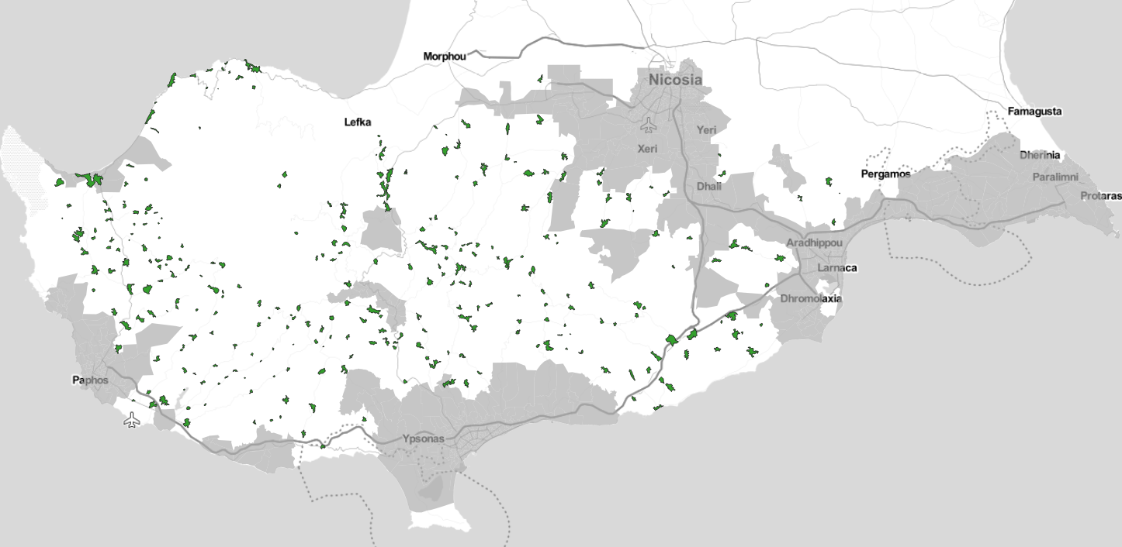
Figure 19: Provisional project scope regarding fixed VHCN coverage
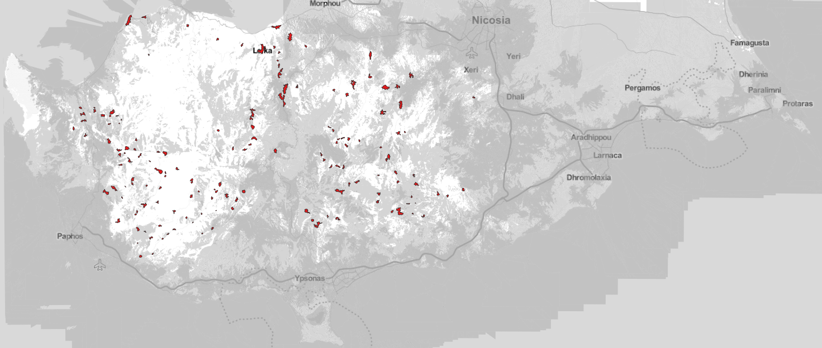
Figure 20: Provisional project scope regarding mobile VHCN coverage
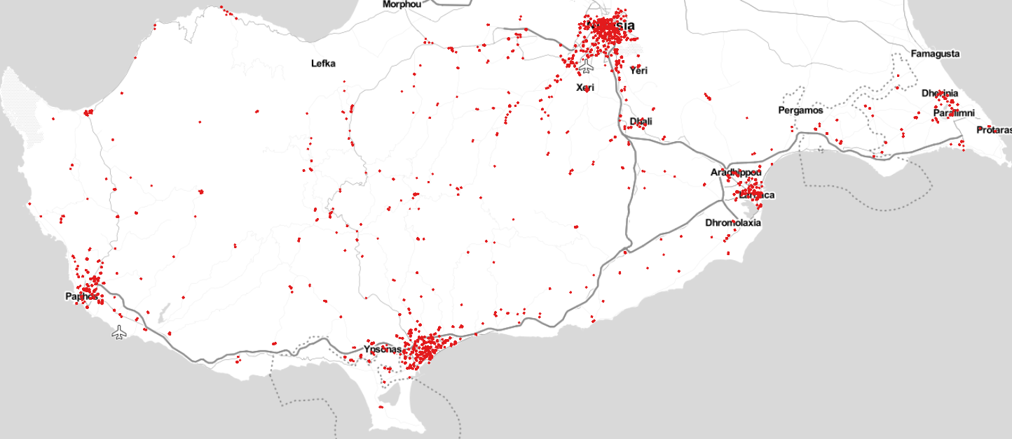
Figure 21: Provisional project scope regarding coverage of socioeconomic drivers

Β2. Enhance building cabling to be “Gigabit-ready” and promote connectivity take-up
Challenges: Although ubiquitous population coverage with Very High Capacity Networks is expected by 2025, through a combination of private investments and public interventions, internal building cabling (to be “Gigabit-ready”) is prerequisite for service take-up.
Objective: The project aims to support end-users to connect with very high capacity networks (VHCN), deployed close to their premises, through the reduction of the setup cost that covers the internal cabling and/or the connection fee of a very high capacity broadband service.
Implementation: The DEC of the DMRID will be the implementing authority. The implementation of the project will follow a demand subsidy (voucher) scheme, addressed exclusively to physical persons (i.e. excluding enterprises) encouraging them to proceed with the construction of their building internal cabling, to be ready for connection to a very high capacity network, passing close to their premises. It applies to single tenant units (STU), as well as apartments in multi-dwelling buildings (MDU) with no internal cabling capable of supporting very high capacity services. The residence owner/tenant will be eligible for a cabling voucher, with specified technical specifications. All vouchers of the owners/tenants in a MDU may be aggregated, in order for the internal cabling to cover all apartments. The redeemed vouchers will be used to pay the certified electrician/installer (as per the OCECPR certification scheme for ‘Installers of intra-building cabling’) who will perform the installation, hired either directly by the building owners, or through a telecom operator. In any case, the internal network will belong to the end-users (either single, or co-owners in case of MDU). Upon completion of the construction, the building will be certified as “Gigabit-ready”.
The subsidy value will be fixed (independently of the actual cost charged by the installer or telecom operator to the end-user), to lower administrative complexity. Thus, the voucher value will be set at a level to be always lower than the actual cost of internal cabling and the actual cost of connection fee. Indicative voucher value is set to 110€ per dwelling unit (either apartment / Multi-Dwelling Unit-MDU or single house / Single-Tenant Unit – STU)
Target population: MDU, STU and end-users located in the entire territory of the Republic of Cyprus will be eligible. Estimated number of beneficiaries is 90K, corresponding to 21% of the total number of premises in Cyprus.
Project Maturity and Timeline: The Project has been included in the Cyprus RRP that was submitted in April 2021 with a provisional budget for public support of 10 Μ€. Final decisions regarding the RRP are expected by 2021 Q3. Detailed project preparation (including cabling technical specifications, definition of the voucher price, project Implementation Guide and IT system) is expected to finish by 2022 Q2 and the voucher is expected to be available from 2022 Q2 until the end of available resources or at the latest 2026 Q2.

Β3. Submarine cable system to Greece
Challenges: The Commission’s Digital Decade targets include strengthening Europe’s global partnerships through the improvement of international connectivity. Cyprus can enhance its role as regional data gateway to the EU for the middle-east countries and the broader region. Despite the fact that several submarine cables land in Cyprus, many, are either old or lack the capacity to cope with the ever-increasing needs of the end-users. Given that the backbone capacity needs are expected to skyrocket with the deployment of ultrafast access infrastructures, telecom and data center operators in Cyprus and the neighboring countries will seek reliable and resilient connections to the main Internet hubs in Europe at competitive prices.
Objectives: The purpose of the project is to create a new submarine link that will connect Cyprus with Greece, where it will be connected to a planned submarine system that will provide interconnection to the region’s most important internet exchanges, including Athens, Sofia and Istanbul. The deployment of a new separate backbone route between Cyprus and Greece, strategically supports connectivity to the most remote member-state of the EU and plays an essential role in ensuring digital connectivity of the island. It will have a significant positive impact on the available capacity and the cost of backbone connectivity, needed to provide very high-speed services to end users of Cyprus and the broader region. Furthermore, it will offer significantly higher performance compared to existing cables, to secure the competitive availability, reliability and resilience of such vital infrastructures. Through this alternative route, it is expected that the capacity of the submarine systems to international telecommunication nodes will be multiplied, while ensuring increased levels of security and resilience for the entire telecommunications infrastructure of the island and the region.
Implementation: The DEC of the DMRID will be the implementing authority. The implementation of the project will follow a Private DBO - gap funding model (i.e. the Contractor will undertake the design, construction and operation of the submarine link, as well as part of the financing, and the public sector will cover the funding gap with a grant), following an open tender procedure. Wholesale obligations will be imposed to the Contractor, as per the State-Aid provisions. Synergies with CEF2 will be exploited through the submission of proposal for funding in the respective CEF2 call.
Target Population: All internet users in Cyprus will potentially be addressed by this new backbone connectivity link.
Timeline: The Project has been included in the Cyprus RRP that was submitted in April 2021 with a provisional budget for public support of 7.5 Μ€. A joint RFI with Greece is launched very soon and expected to complete by 2021 Q2. Final decisions regarding the RRP are expected by 2021 Q3. Detailed studies to be performed in 2022-2023. Tender is expected in 2023 Q4. Seabed geophysical survey for the cable route (to be performed by the contractor) and Approvals/Licensing (to be obtained by the contractor) are expected to finish by 2024 Q4. Construction is expected to start by 2025 Q1 and finish by 2025 Q4.

B4. Address the affordability of ultrafast services
Challenges: Although ubiquitous population coverage with Very High Capacity Networks is expected by 2025, through a combination of private investments and public interventions, service affordability is prerequisite for take-up.
Objective: The project aims to support low-income end-users to subscribe to ultrafast broadband services, through the reduction of the setup and monthly fee of such services.
Implementation: The DEC of the DMRID will be the implementing authority. The implementation of the project will follow a demand subsidy (voucher) scheme, addressed exclusively to physical persons (i.e. excluding enterprises) encouraging them to subscribe for the first time to ultrafast services (at least 250 Mbps). The project will be implemented through the same approach that was followed in the pilot “demand voucher” scheme that was implemented in 2019/20 (https://superfast.cut.ac.cy/). Extensive know-how has been acquired, both from the Managing Authority and the market. The voucher price will be set at a level to absorb the price difference between the ultrafast service and the respective 100 Mbps service for a year as well as the respective connection fee (indicatively, 300 euros to account of 20 euros for a duration of 12 months and around 60 euros for the connection fee).
The subsidy value will be fixed (independently of the actual cost / package that will be selected by the end-user), to lower administrative complexity.
Target population: End-users that fulfil the Income and Property criteria for the student care allowance, as in force. Estimated number of beneficiaries is 66K, corresponding to 15% of the total number of premises in Cyprus.
Project Maturity and Timeline: The Project will been included in the ERDF that will submitted in Q2 2021 with a provisional budget for public support of 20 Μ€. Final decisions regarding the ERDF programme are expected by 2021 Q3. Detailed project preparation (including project Implementation Guide and IT system) is expected to finish by 2022 Q2 and the voucher is expected to be available from 2022 Q2 until the end of available resources or at the latest 2026 Q2.

B5. Facilitate the installation of Data Center infrastructures
Challenges: The Commission’s Digital Decade targets include strengthening Europe’s global partnerships through the offer of EU data storage and processing services to partners outside of Europe. Cyprus can evolve as regional hub of Data Center facilities for the middle-east countries and the broader region. In order to facilitate the installation of such facilities, three major challenges must be addressed: Real estate, high quality international connectivity and power availability. Countries like Spain, Sweden, India and Singapore have already developed such policies with considerable success.
Objective: The purpose of the project is to create a Green Data Center Park in order to attract large-scale Data Center operators to invest in Cyprus in computer hosting facilities. It will have a significant positive impact on the development of the sector and its transformation to a catalyst for the development of the digital economy as a whole.
Implementation: The Department of Electronic Communications (DEC) of the Deputy Ministry of Research, Innovation and Digital Policy (DMRIDP) will be the coordination and implementation authority. The government will promote the construction of the Green Data Center Park by providing land and other facilities (i.e. renewable power production and storage infrastructures, connectivity with submarine cable landing stations, pre-licensed sub-sea corridor for submarine cables, sea-water cooling facilities, fencing etc) in conjunction with administrative measures to facilitate issuing of building permit and reliable access to the power grid. The Data Center Park will address the whole range of prerequisites that are required in order to facilitate fast and cost-effective deployment of new large-scale data centres.
The project will take the form of a Public Private Partnership, where the Public partner will provide the land, establish a favorable administrative environment and assume part of the funding. The Private partner (to be selected through an open request for interest) will design, finance, build and operate the Date Center Park.
Target population: All internet users in Cyprus as well as the broader economy will be benefited by the installation of Data Centers on the island.
Project Maturity and Timeline: The Project will been included in the ERDF that will submitted in Q2 2021 with a provisional budget for public support of 20 Μ€. Final decisions regarding the ERDF programme are expected by 2021 Q3. Detailed project preparation (including the business planning, land selection and concession and the technical studies) is expected to finish by 2022 Q4. The PPP tender is expected to be assigned on 2023 Q2 and complete by 2024 Q4.

Governance
The National Broadband Plan was developed by the DEC of the DMRID, who will be the responsible governmental entity for implementing the Plan.
The National Broadband Plan includes measures of highest priority and significance for the digital transition of Cyprus and, thus, focus should be given to ensure its successful and timely implementation by setting-up a governing body fully responsible for its day-to-day execution. It is proposed that the DEC, as the designated Broadband Competence Office - BCO will assure the role of the governing body with regards the implementation of the Plan. The BCO will be responsible to:
- support the everyday operations and perform all the necessary administrative functions;
- monitor the implementation of the measures included in the Plan by defining the appropriate performance indicators;
- provide periodic reports to the Government as regards the implementation of the Plan;
- address the level of complexity by providing best practice advice and guidance to local and governmental authorities;
- identify risks and suggest the appropriate measures;
- coordinate with other ministries, governmental and local authorities with the aim to facilitate the timely and successful implementation of the Plan and to remove any potential obstacles that might hinder it;
- coordinate public events and communication campaigns, when appropriate, to publicise the actions included in the Plan as well as their benefits.
The BCO will be directly reporting to the DMIRD and will be staffed by public servants with extensive knowledge as regards the relevant policy areas of the Plan and the necessary project management skills. Moreover, staff from the OCECPR will provide technical assistance and interface with the OCECPR as regards policy areas that require common action.
The BCO will be responsible for the central monitoring of all standard indicators for monitoring the progress of the Broadband Plan, gathering all the relevant data from all the bodies that primarily monitor the individual indicators.

Security considerations
Since September 2020, Cyprus has a comprehensive legal framework in place related to the national implementation of the EU 5G Toolbox, including specific measures for the assessment of the risk profile of 5G equipment suppliers, relevant restrictions for suppliers considered to be high-risk (including provisions for key assets that have been classed as critical and sensitive, strict additional security requirements for mobile network operators and obligations for mobile network operators to develop appropriate multi-vendor strategies (Decision 408/2020). The above framework is applicable in all the actions involving deployment of 5G and if necessary it will be applied and/or adapted for the other actions included in the Broadband Plan (i.e. the submarine cable), in close collaboration with the Digital Security Authority.
Following the principles of the existing legislation, this will enforce strict requirements on the investments, as to:
(i) the risk profile of supplier(s), relevant restrictions for suppliers considered to be high risk - including necessary exclusions to effectively mitigate risks - for key assets defined as critical and sensitive in the EU coordinated risk assessment: Potential suppliers that may be involved in the investments will go through a tailored screening process, with a detailed and specific set of criteria being applied to determine if any of these potential suppliers are deemed to present high risk. These criteria are closely linked to the provisions of the 5G Toolbox. Key assets will be identified separately for each investment, with relevant exclusions and other restrictions being codified to effectively mitigate the risks that may be present.
(ii) the security requirements for mobile network operators (e.g. strict access controls, rules on secure operation and monitoring, limitations on outsourcing of specific functions, etc.): The additional security requirements for mobile network operators, that form part of Decision 408/2020 (national secondary legislation), will be applied and, if necessary, adapted to make specific provisions for the type of connectivity that is being proposed as part of each specific investment. In addition, for investments that are to be classified as part of critical information infrastructure, all background obligations that are present for Operators of Essential Services and additional requirements that are currently being developed for all types of electronic communications networks and services providers will also be in force.
(iii) an appropriate multi-vendor strategy to avoid or limit any major dependency on a single (high-risk) supplier, ensure an adequate balance of suppliers at national level, and avoid any situations of lock-in with a single supplier: For the company (or consortium) which will be involved in each investment, the legislation requires that an appropriate multi-vendor strategy be developed and submitted to the authorities for approval before any final procurement decisions are made. The minimum content of this multi-vendor strategy is defined in the legislation, and will take into account the project and its components as a whole, to limit any major dependency on a single high-risk supplier and to ensure an adequate balance of suppliers at the national level. In addition, the strategy must consider not just the infrastructure itself, but its interconnection to local and remote networks, depending on the final selected topologies. In all cases, the multi-vendor strategy will be accompanied by a risk analysis and specific actions to mitigate any risks identified that are related to the suppliers involved, but also for the secure deployment and operation of the investments over their projected lifetime.

Abbreviations
5G NSA | 5G Non-Stand-Alone
5G SA | 5G Stand-Alone
AR | Augmented Reality
BCO | Broadband Competence Office
BEREC | Body of European Regulators of Electronic Communications
BP | Best Practice
CBR | Cost Benefit Ratio
CEF2 | Connecting Europe Facility 2
DBO | Design-Build-Operate
DEC | Department of Electronic Communications
DESI | Digital Economy and Society Index
DMIRD | Deputy Ministry of Innovation Research and Digital Policy
DOCSIS | Data Over Cable Service Interface Specification
DSL | Digital Subscriber Line
ECN | Electronic Communication Networks
EECC | European Electronic Communications Code
eMBB | Enhanced Mobile Broadband
ERDF | European Regional Development Fund
EU | European Union
FTTB | Fiber to the Building
FTTH | Fiber to the Home
FTTP | Fiber to the Premises
FWA | Fixed Wireless Access
GB | Gigabytes
GBps | Gigabit per second
GDP | Gross Domestic Product
G-PON | Gigabit Passive Optical network
ICT | Information and Communication Technologies
IoT | Internet of Things
IPTV | Internet Protocol TV
ITU | International Telecommunications Union
Mbps | Megabits per second
MDU | Multi-Dwelling Unit
MFF | Multianual Financial Framework
mMTC | massive Machine Type Communications
MNO | Mobile Network Operator
MVNO | Mobile Virtual Network Operator
NFV | Network Function Virtualisation
NGA | Next Generation Access networks
NRA | National Regulatory Authority
OCECPR | Office of the Commissioner for Electronic Communications and Postal Regulation
P2MP | Point-to-Multipoint
P2P | Point-to-Point
POP | Point-of-Presence
RFI | Request For Information
RRF | Recovery and Resilience Facility
RRP | Recovery and Resilience Program
SE Mediterranean | South Eastern Mediterranean
SIP | Single Information Point
STU | Single Tenant Units
SWOT | Streangths, Weaknesses, Opportunities and Threats
URLLC | Ultra Reliable Low Latency Communications
VDSL | Very-high-bitrate Digital Subscriber Line
VHCN | Very High Capacity Networks
VSAT | Very Small Aperture Terminals

Endnotes

On average, GDP in the E.U. fell by 6.2%, with strong variation between individual countries while the seasonally adjusted unemployment rate reached 7.5% in December 2020 up from 6.5% the year before. In Cyprus, GDP fell by 5.1%, and the seasonally adjusted unemployment rate reached 7.3% up from 6.3%. Source: Eurostat press release, 16/2/2021.
“Regaining eminence and emerging stronger”, Accenture, August 2020.
OCECPR press release, 24/3/2021, Increase of weekly average of data volume for the period March 2020-March 2021, as compared with the weekly average of the semester prior the pandemic
DESI 2020, source: European Commission
In the context of the Broadband Plan, the term ‘ultrafast’ is used to denote broadband speeds of at least 100 Mbps downstream which can be upgraded to 1Gbps downstream and the term ‘fast’ to denote broadband speeds of at least 30 Mbps downstream
DESI 2020 Connectivity dimension, source: European Commission
Article 2 (2) European Electronic Communications Code - DIRECTIVE (EU) 2018/1972
Network performance can be considered similar regardless of whether the end-user experience varies due to the inherently different characteristics of the medium by which the network ultimately connects with the network termination point.
BoR (20) 165, BEREC Guidelines on Very High Capacity Networks
Fibre to the building (FTTB): an access network architecture in which the intra-building connection is a physical medium other than optical fibre (such as coaxial cable or twisted-pair cable over which DOCSIS 3.1 or g.fast technologies are used). The fibre optic communications path is terminated within a single building for the purpose to offer communication services for potentially multiple subscribers within the building.
Fibre to the home (FTTH): an access network architecture in which end-to-end connection to the subscriber premises is optical fibre. The fibre optic communications path is terminated inside the premises of the subscriber for the purpose to offer communication services to a single subscriber.
According to BEREC Guidelines (BoR (20) 165), it is considered as VHCN any network providing a fixed-line connection which is capable of delivering, under usual peak-time conditions, services to end-users with the following quality characteristics: Downlink data rate ≥ 1000 Mbps, Uplink data rate ≥ 200 Mbps, IP packet error ratio (Y.1540) ≤ 0.05%, IP packet loss ratio (Y.1540) ≤ 0.0025%, Round-trip IP packet delay (RFC 2681) ≤ 10 ms, IP packet delay variation (RFC 3393) ≤ 2 ms, IP service availability (Y.1540) ≥ 99.9% per year.
According to BEREC Guidelines (BoR (20) 165), it is considered as VHCN any network providing a wireless connection which is capable of delivering, under usual peak-time conditions, services to end-users with the following quality characteristics: Downlink data rate ≥ 150 Mbps, Uplink data rate ≥ 50 Mbps, IP packet error ratio (Y.1540) ≤ 0.01%, IP packet loss ratio (Y.1540) ≤ 0.005%, Round-trip IP packet delay (RFC 2681) ≤ 25 ms, IP packet delay variation (RFC 3393) ≤ 6 ms, IP service availability (Y.1540) ≥ 99.81% per year.
FTTH accounts for ~60% of global homes passed and FTTB for ~40% , source: FTTH Forecast for EUROPE, FTTH council Europe
Current share of P2MP is 50% of global homes passed but is expected to reach 76% by 2026 (with the rest 50% and 24% respectively for P2P topologies), source: FTTH Forecast for EUROPE, FTTH council Europe
source: FTTH Forecast for EUROPE, FTTH council Europe
Openvault Broadband Insights Report (OVBI)
OCECPR Statistical Bulletin for fixed telephony and broadband services, March 2021, graph 8, excluding IPTV and Cable TV
https://tefficient.com/the-growth-in-mobile-data-wasnt-stopped-by-a-pandemic/
The socio-economic impact of FTTH, 2018, WIK-Consult GmbH
87% mentioned high bandwidth as the primary reason for purchasing a FTTH connection, 62% said they were satisfied about the higher range of services they get with FTTH and 51% were of the view that fibre provides better value for money
Satisfaction reported at 83% in comparison with DSL or cable, which were respectively reported at 52% and 72%.
89% of FTTH users in Sweden are online every day and on average are 11% more active online
30% and 35% of Swedes watch videos and listen to music solely over the Internet compared to 10% and 21% respectively in Germany
FTTH-enabled digital home care — A study of economic gains. Forzati, M., & Mattsson
Broadband Consumer Research, RVA (2011)
Early Evidence Suggests Gigabit Broadband Drives GDP, Analysis Group
Broadband Speed and Unemployment Rates: Data and Measurement Issues, Lobo, Whitacre, April 2019
Impact of Very High-Speed Broadband on Local Economic Growth: Empirical Evidence, Hasbi, 2017,
Ultra-fast broadband, skill complementarities, gender and wages, Motu Economic and Public Policy Research , December 2019
2.9 % expected increase in employment from full FTTP roll-out (Source: Singer, H., Caves, K., & Koyfman, A. (2015). The Empirical Link Between Fibre-to-the-Premises Deployment and Employment: A Case Study in Canada).
Energy consumption in wired and wireless access networks. IEEE Communications Magazine, 49(6), 70–77,
Build Fibre, Save energy!, FTTH council Europe Press-release
Copper switch-off refers to the decommissioning of legacy copper cables in the access network and the shut down of the copper-based MDFs (local exchanges). In case of a complete copper switch-off, customers are migrated to fibre networks. In case of partial switch-off (this is the case where operators have upgraded part of the access network to fibre (through FTTC/VDSL)), only the legacy copper “feeder” network is decommissioned.
IMT Vision – Framework and overall objectives of the future development of IMT for 2020 and beyond, ITU
5G Commercial Networks Are Now Live In More Than 60 Countries, Press-release GSA 11/2/2021
Massive Expansions and Huge Improvements in Speed: The Worldwide Growth of 5G in 2020, Speedtest, Ookla
5G Observatory Quarterly Report 10, up to December 2020
5G action plan review for Europe, Analysys
Cisco Annual Internet Report (2018–2023) White Paper, March 2020,
Ericsson Mobility Report, November 2020
5G for Europe: an Action Plan, European Commission
5G Readiness Report, Nokia, 2020
The Impact of 5G: Creating New Value across Industries and Society, World Economic Forum, January 2020
Shaping the digital transformation in Europe, European Commission, September 2020
The Impact of 5G on the European Economy, Accenture, February 2021
Identification and quantification of key socio-economic data to support strategic planning for the introduction of 5G in Europe, study for the European Commission
direct impact, which captures the effect that is generated directly from investment expenditure on 5G infrastructure and services
Type II multiplier effect, which captures the change in consumers’ spending and consumption of goods and services as a result of the higher household income and investment expenditure. Type II Multiplier = (Direct Effect + Indirect Effect +Induced Effect) / Direct Effect
Type I multiplier effect, which captures the intermediate flows within the supply chain, such as goods and services needed to deploy 5G infrastructure and services. The indirect effect measures the increased production and supply of services within the supply chain to operate the systems and provide 5G connections. Type I Multiplier = (Direct Effect + Indirect Effect) / Direct Effect
COM(2016) 587 Connectivity for a Competitive Digital Single Market - Towards a European Gigabit Society
COM(2021) 118 2030 Digital Compass: the European way for the Digital Decade
Common Union toolbox for Connectivity pursuant to Commission Recommendation of 18.9.2020 on a common Union toolbox for reducing the cost of deploying very high capacity networks and ensuring timely and investment-friendly access to 5G radio spectrum, to foster connectivity in support of economic recovery from the COVID-19 crisis in the Union
Commission recommendation 2020/1307 on a common Union toolbox for reducing the cost of deploying very high capacity networks and ensuring timely and investment-friendly access to 5G radio spectrum, to foster connectivity in support of economic recovery from the COVID-19 crisis in the Union
Connecting Europe Facility (CEF2) Digital
Στατιστικό Δελτίο για την παρακολούθηση της Σταθερής Τηλεφωνίας και Σταθερής Ευρυζωνικής Πρόσβασης μέχρι τον Δεκέμβριο 2020, Επίτροπος Επικοινωνιών
Digital Economy and Society Index 2020 - Telecom Chapter
Broadband Coverage in Europe 2019, Final Report prepared for the European Commission
Mobile and Fixed Broadband Prices in Europe 2019, A study prepared for the European Commission by Empiric and TUV Rheinland
E.g. Cyta offers on the fiber network, the Internet Home 150 Mbps service at a price of 29.24 euros per month (and Internet Home 250Mbps at 39.64 euros per month), whereas on the copper network the Internet Home 100Mbps service is offered at 55.40 euros per month.
Cablenet, after having operated as an MVNO for some years, was granted a new mobile license through an auction procedure in June 2020, where 2x10 MHz in the 800 MHz band, 2x20 MHz (FDD) and 15 MHz (TDD) in the 2.6 GHz band were assigned
Study on Broadband Coverage in Europe 2019 SMART 2019/0020 , Final Dataset, sheet ‘BCE 2019 Percentage coverage’ retrieved from here. The study includes two indicators for LTE coverage and both are used in Cyprus scoreboard, albeit in a confusing way. The first, ‘LTE’, is an aggregate indicator, i.e. measuring the coverage of all operators together and is used in country’s ‘Telecoms chapters’, while the second ‘Average LTE coverage’ is an average indicator, i.e. the sum of all coverages divided by the number of operators and is used in ‘DESI Country profile‘. We use the first indicator, ‘LTE’, in the present report.
Cyta press release, 4/7/2018
Cyta press release, 19/4/2019
Cyta press release, 11/1/2021
Cyta press release, 31/1/2021
Cablenet was assigned 2x10 MHz in the 800 MHz band, 2x20 MHz (FDD) and 15 MHz (TDD) in the 2.6 GHz band and subsequently published a request for proposals (RFP) to the other three mobile operators for radio access network (RAN) sharing agreements as well as an RFP to equipment suppliers for building a new RAN. Source: Digital Economy and Society Index 2020 - Telecom Chapter
EPIC press release, 2/4/2021
EPIC press release, 9/3/2021. Passive infrastructure includes elements such as mobile towers and masts. Epic will retain ownership of its base stations, antennas and related active telecommunications equipment. The transaction also includes the acquisition of the passive mobile infrastructure of EPIC Malta by Phoenix Towers International, and the combined portfolio of Epic Cyprus and Epic Malta includes 815 stations. The transaction is expected to be completed by the end of 2021.
Διαγωνισμός THE Δ1/2020 - Ανακήρυξη Προσωρινών Νικητών, Announcement by the DEC
Highways are the main traffic routes of the Republic of Cyprus, contain 2 or 3 lanes per direction and are numbered with the prefix Α (e.g. Α1, Α2, etc.)
Main roads are usually deployed parallel to the Highways and are numbered with the prefix B (e.g. B1, B2, etc.). They usually contain 1 lane per direction, expect in some cases near inhabited areas where they contain 2 lanes per direction
Cyta press release, 20/11/2020
Telegeography submarine cable map , Infrapedia, Subtel Cable map
which provide satellite links in the C, Ku, DBS and Ka frequency bands, source: Cytaglobal presentation
Cyta press release, 18/2/2020
Datacenter Map
Cloudscene for Cyprus, Egypt, Israel, Greece and Bulgaria
Global internet map 2021, Telegeography
Digital Economy and Society Index, EU Commission
Investment plans up to 2025 were requested
calculation is based on applying a multiplier factor of 135%, which is the percentage of all premises across Cyprus versus the number of subscriber lines
Total premises= 433212, Source: Cyprus Statistics Authority, 2011 Census, Table Γ3
Total lines= 321568, Source: Στατιστικό Δελτίο για την παρακολούθηση της Σταθερής Τηλεφωνίας και Σταθερής Ευρυζωνικής Πρόσβασης για το 1ο εξάμηνο 2020, Επίτροπος Επικοινωνιών
The implementation roadmaps should (i) present an initial assessment by the Member State as to the usefulness of the best practices according to the national situation, (ii) overall reflect the expected plan of the Member State, based on its initial assessment, in regard to the implementation of the best practices and (iii) provide an indicative timing and potential stakeholders for implementation.
5G action plan review for Europe: final report, 2020, Analysys Mason
The study notes that “while we can account for country-specific differences using high-level modelling inputs (GDP per capita, sectoral GDP, sites, traffic, number of use-case location etc.), specific dynamics in individual countries (e.g. level of digitisation in certain sectors of the economy) have not been captured. Modelling inputs have not been available for all countries (in which case European averages have been used). Individual country results should therefore be treated with caution.”
Eurostat 2019, indicator NAMA_10_A10
Eurostat 2016, Farms and farmland in the European Union – statistics
Gigabit connectivity means the provision of a 1 Gbps symmetric Internet access service (1GBps download speed and 1Gbps upload speed) that is offered in a cost effective way.
The main socio-economic drivers include primary and secondary schools, higher education facilities (universities, technological institutes), central and local government buildings, hospitals, medical centers, business parks, airports and stadiums.
Premises are defined as all permanent constructions that house households or businesses within the boundaries of organized communities as well as active enterprises that employ more than 10 employees, even if they are outside the boundaries of organized communities.
"speed" refers to "nominal" speed of the broadband service
The major terrestrial transport paths in Cyprus are defined as the Highways (routes designated with ‘Α’ prefix) and main roads (routes designated with ‘B’ prefix).
This speed should be available per user in any location of the covered area under usual peak time conditions
The indicators coincides with DESI ‘1a2 At least 100 Mbps fixed BB take-up’ indicator and will be calculated based on the same methodology
A Broadband Competence Office (BCO) is a public/publicly-appointed entity that should be able to inform citizens and businesses about broadband developments/deployments in the country/region. BCOs also provide technical support (regulatory, investment models, procurement, technology, etc) to local and regional authorities about means to support the deployment of broadband networks, including ways to invest effectively in broadband projects with the support of European regional and agricultural funds (ERDF and EAFRD), in combination with financial instruments where possible, and including information on State aid rules and procedures.
OCECPR Certification scheme regulation - Installer of intra-building cabling infrastructure (ΥΕΚΟ)
Student Care service, Ministry of Education, Culture, Sports and Youth
Modular Data Center Park Planned for Barcelona, Datacenter knowledge
Node Pole
Government to unveil policy on data center parks, The Times of India, The Indian Government Plans to Open Data Center Parks in India, Analytics Insight
Singapore Data Center Park is now Tanjong Kling, Datacentre Dynamics

